Airbnb Price Prediction, Guest Sentiment Analysis & Topic Modeling using ML, NLP & Neural Networks
Group 5:
Rohith Reddy Kolanu
Allen Joe Winny Tharigopala
Ruthwik Reddy Kolanu
Gianni Colonero

Problem Statement
The first objective of this project is to conduct a Guest Experience Analysis using Natural Language Processing (NLP) techniques on Airbnb review data from Chicago, Illinois. Online reviews provide valuable unstructured insights into guest perceptions of cleanliness, service quality, location convenience, and overall satisfaction. Through systematic text preprocessing, sentiment analysis, zero-shot classification, and topic modeling qualitative review content will be transformed into measurable indicators of customer experience while also identifying the key themes frequently discussed by guests. The analysis will examine sentiment patterns across amenities and property types and evaluate their relationship with listing performance. The findings aim to provide actionable insights for hosts to improve service quality and strengthen their competitive position in the marketplace.
The second objective of this project is to develop a neural networks and machine learning model to predict Airbnb listing prices in Chicago, Illinois, United States using structured property characteristics and indicators derived from guest reviews. Pricing plays a critical role in revenue optimization, occupancy performance, and competitive positioning in short-term rental markets. Using the Listings dataset, variables such as property type, room type, and host attributes will be incorporated into a regression framework to identify the key determinants of listing prices. In addition, sentiment scores, zero-shot classification scores, and topic-based scores derived from the reviews dataset using sentiment analysis, zero-shot classification and LDA topic modeling will be incorporated into the price prediction model to evaluate whether guest perceptions, experiences, and latent thematic patterns improve predictive accuracy and influence listing valuation.
Tools, Libraries, and Environment Setup
The analysis was conducted entirely in Python, leveraging a comprehensive set of open-source libraries suited for data manipulation, natural language processing, machine learning, and deep learning tasks.
Data Manipulation and Numerical Computing: The pandas library was used for loading, cleaning, and transforming structured tabular data, while numpy provided support for numerical array operations and mathematical computations throughout the pipeline.
Data Visualization: Visualizations were produced using matplotlib and seaborn, which together enabled the creation of static statistical plots including distribution charts, heatmaps, and box plots. The plotly.express library was additionally used for interactive visual exploration of patterns in the data.
Machine Learning and Model Evaluation: The scikit-learn library served as the foundation for data preprocessing workflows, including train-test splitting via train_test_split, as well as model evaluation using standard regression metrics such as Mean Squared Error (mean_squared_error), Mean Absolute Error (mean_absolute_error), and the R-squared coefficient (r2_score).
Deep Learning: Neural network models were constructed and trained using TensorFlow and its high-level Karas API. Key components utilized included the Sequential model architecture, fully connected Dense layers, BatchNormalization, Dropout regularization, the Adam optimizer, and EarlyStopping callbacks to prevent overfitting during training.
All warnings were suppressed during execution to maintain clean and readable output, and the seaborn plotting style was globally set to whitegrid to ensure visual consistency across all figures.

Data Loading
The datasets were sourced from Inside Airbnb, an open-data platform publishing publicly available Airbnb data for cities worldwide. The Chicago, Illinois snapshot dated September 22, 2025, was used for this analysis.
Two datasets were loaded directly from the Inside Airbnb website into Python:
Listings Dataset: Contains structured property-level information for active Chicago Airbnb listings, including property type, room type, host attributes, pricing, availability, and review scores. This dataset serves as the primary input for the price prediction model.
Reviews Dataset: Contains guest-written textual reviews linked to individual listings, forming the foundation for all NLP tasks including sentiment analysis, zero-shot classification, and topic modeling.
Both files were retrieved in compressed .gz format and loaded into pandas DataFrames using the compression='gzip' parameter, referenced throughout the analysis as listings_df and reviews_df.

Initial Sanity Checks of Reviews Dataset
The Reviews Dataset was initially found to contain 492,465 records across 6 columns: listing_id, id, date, reviewer_id, reviewer_name, and comments.
A missing value check revealed that all columns were complete except for the comments column, which contained 164 null entries. Since the comments column serves as the primary input for all NLP tasks, rows with missing values were removed using the dropna() function. Following this operation, the cleaned dataset retained 492,301 records, representing a negligible data loss of less than 0.04% of the original dataset. All remaining columns contained no missing values, confirming that the dataset was otherwise complete and ready for further preprocessing and analysis.

Reviews Over Time (Time Series Plot)

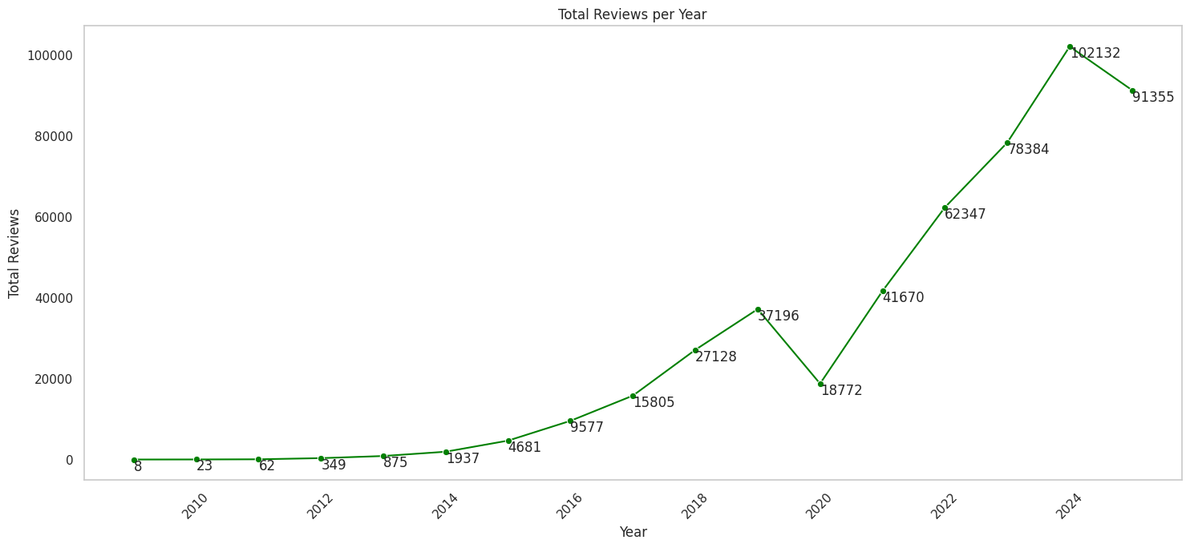

Figure 1
Figure 1 illustrates the total number of guest reviews submitted per year for Chicago Airbnb listings, spanning from 2009 to 2025.
Figure 1: Total Reviews per Year
The data reveals a clear growth trajectory in platform engagement over the observed period. Review activity was minimal in the early years, with only 8 reviews recorded in 2009, gradually increasing to 4,681 by 2015 as the platform gained traction in the Chicago market. Growth accelerated significantly between 2016 and 2019, with annual reviews rising from 9,577 to 37,196, reflecting rapid expansion in both host participation and guest activity.
A notable decline to 18,772 reviews was observed in 2020, which is directly attributable to the global disruption caused by the COVID-19 pandemic and the widespread reduction in travel activity during that period. The market recovered sharply in subsequent years, with review volumes rebounding to 41,670 in 2021 and continuing to climb, reaching a peak of 102,132 reviews in 2024. A slight decrease to 91,355 was recorded in 2025, which may reflect the partial year of data available at the time of the dataset snapshot rather than an actual decline in market activity.
Overall, the trend confirms strong and sustained growth in Chicago's short-term rental market, underscoring the increasing relevance of guest review data as a source of insight for hosts, guests, and platform stakeholders alike.

Filtering the Most Recent Reviews
To ensure the NLP analysis reflects current guest perceptions and market conditions, the dataset was filtered to retain only reviews submitted during the years 2023, 2024, and 2025. This decision was informed by the time series analysis presented in Figure 1, which demonstrated that most of the review activity is concentrated in the most recent years, making older reviews less representative of the current state of the Chicago Airbnb market.
Following this filtering step, the working dataset was reduced to 271,871 records across 7 columns, covering 6,705 unique Airbnb listings. This subset provides a sufficiently large and temporally relevant corpus for conducting sentiment analysis, zero-shot classification, and topic modeling while also ensuring that the derived NLP features accurately reflect contemporary guest experiences and expectations.

Aggregating Reviews at the Listing Level
To enable listing-level NLP analysis, individual reviews were aggregated into a single consolidated text entry per listing. The dataset was first sorted by listing_id and review date in descending order to prioritize the most recent guest feedback. The top 20 reviews per listing were then retained, ensuring that each listing's representation was based on its latest and most relevant guest experiences without allowing high-volume listings to disproportionately dominate the analysis.
The selected reviews for each listing were subsequently concatenated into a single combined text string using a space delimiter, producing one unified comment field per listing. Following this aggregation, the dataset was restructured into a compact format containing two columns, listing_id and comments, with a final shape of 6,705 rows, confirming that each of the 6,705 unique listings identified in the filtering step was represented by exactly one aggregated review entry. This listing-level representation formed the input corpus for all downstream NLP tasks.

Text Preprocessing
Prior to applying NLP techniques, the aggregated review comments underwent a systematic text preprocessing pipeline to transform raw, unstructured text into a clean and standardized format suitable for analysis. The following steps were applied sequentially to each review entry:
URL and Special Character Removal: Regular expressions were used to strip any URLs and non-alphabetic characters from the text, retaining only meaningful words and whitespace.
Lowercasing: All text was converted to lowercase to ensure consistency and prevent the same word in different cases from being treated as distinct tokens.
Tokenization: Each review was split into individual tokens using whitespace-based splitting.
Stopword Removal: Standard English stopwords from the NLTK corpus were combined with a custom set of project-specific stopwords tailored to the Airbnb and Chicago context. The custom stopwords included generic descriptors such as "great," "nice," and "amazing," property-related terms such as "room," "apartment," and "bathroom," and Chicago-specific place names such as "downtown," "riverwalk," and "millennium." Removing these high-frequency but low-information terms ensured that the resulting analysis would surface more meaningful and discriminating themes from the reviews.
Lemmatization: The WordNetLemmatizer from NLTK was applied to reduce each token to its base dictionary form, consolidating variations of the same word and improving the quality of downstream frequency-based and topic modeling analyses.
The NLTK resources required for this pipeline, including the stopword corpus, WordNet lexical database, and Open Multilingual WordNet, were downloaded prior to execution. The fully preprocessed text was stored back into the comments column of reviews_df and used as the input for all subsequent NLP tasks.

HTML Tag Removal
As an additional preprocessing step, the review comments were inspected and cleaned for embedded HTML content. Since the Inside Airbnb dataset aggregates review text that may have been submitted through web interfaces, some entries contained HTML entities and markup tags that would introduce noise into the NLP pipeline if left unaddressed.
A dedicated clean_html() function was defined to handle this. The function first verified that each entry was a valid string, returning an empty string for any non-text or missing values. HTML entities such as &amp; and &nbsp; were decoded using Python's built-in html.unescape() function, and any residual HTML tags were subsequently removed using BeautifulSoup with the html.parser backend, which extracted only the plain readable text content. Trailing whitespace was removed as a final step before returning the cleaned string. The function was applied to the entire comments column, ensuring that all review text entered the NLP analysis pipeline in a clean, markup-free format.

Language Detection and Filtering
To ensure linguistic consistency across the NLP pipeline, a language detection step was applied to identify and retain only English-language reviews. Since the aggregated review corpus contained contributions from international guests, processing non-English text through English-trained sentiment and topic models would have introduced inaccurate and misleading results.
Language detection was performed using the papluca/xlm-roberta-base-language-detection model, a multilingual transformer-based text classification model sourced from Hugging Face. The model was applied to all review entries in batches of 64, with input truncated to a maximum of 512 tokens. The predicted language label and its associated confidence score were stored as new columns in reviews_df.
The language distribution analysis revealed that the dataset spanned 14 detected languages. English was the dominant language, accounting for 5,982 listings (89.22%) of the dataset. Non-English reviews collectively represented the remaining 10.78%, with Spanish being the most prevalent non-English language at 3.98%, followed by German at 1.83% and French at 1.49%. Following detection, the dataset was filtered to retain only English-language entries and the auxiliary language and score columns were dropped. The final preprocessed dataset comprised 5,982 records across 2 columns, representing the clean, English-only listing-level review corpus used as input for all subsequent NLP analyses.

Sentiment Analysis Using VADER
Sentiment analysis was conducted using the VADER (Valence Aware Dictionary and sEntiment Reasoner) lexicon-based sentiment analyzer, sourced from the vaderSentiment library. VADER is particularly well-suited for short, informal, and user-generated text such as online reviews, as it is specifically calibrated to handle colloquial language, punctuation emphasis, and degree modifiers without requiring model training.
The SentimentIntensityAnalyzer was applied to each listing's aggregated review text, producing four sentiment scores per entry: the compound score, which represents a normalized overall sentiment value ranging from -1 (most negative) to +1 (most positive), along with individual positive, neutral, and negative proportion scores. These four scores were stored as new columns in a dedicated copy of the reviews dataset named vader_sentiment_reviews_df.
Each listing was subsequently classified into one of three sentiment categories based on the compound score. Listings with a compound score of 0.05 or above were labeled as POSITIVE, those with a score of -0.05 or below were labeled as NEGATIVE, and all remaining entries were classified as NEUTRAL. This thresholding convention follows the standard VADER classification guidelines.
The sentiment distribution results revealed a strongly positive overall landscape across Chicago Airbnb listings. Of the 5,982 listings analyzed, 5,769 (96.44%) were classified as POSITIVE, while 108 (1.81%) were classified as NEGATIVE and 105 (1.75%) as NEUTRAL. This distribution reflects the general tendency of guests who complete stays to leave favorable reviews, and confirms that the Chicago Airbnb market is characterized by predominantly positive guest experiences during the 2023 to 2025 period.

Sentiment Analysis Using Hugging Face Transformers
To complement the lexicon-based VADER analysis, a transformer-based sentiment analysis model was applied using the Hugging Face transformers library. Unlike VADER, which relies on a predefined dictionary of sentiment-bearing words and rules, transformer-based models leverage deep contextual representations learned from large-scale pretraining, enabling more nuanced understanding of language and sentiment within longer, more complex text sequences.
The default sentiment-analysis pipeline from Hugging Face, based on the distilbert-base-uncased-finetuned-sst-2-english model, was used to classify each listing's aggregated review text. Each review was truncated to a maximum of 512 tokens to comply with the model's input length constraint. The model returned a predicted sentiment label of either POSITIVE or NEGATIVE along with a confidence score, both of which were stored as new columns in a dedicated copy of the dataset named huggingface_sentiment_reviews_df.
The resulting sentiment distribution showed that 4,065 listings (67.95%) were classified as POSITIVE and 1,917 listings (32.05%) were classified as NEGATIVE. Compared to the VADER results, the Hugging Face model produced a notably higher proportion of negative classifications, which reflects a key difference between the two approaches. Since the review text had been preprocessed by removing common positive adjectives such as "great," "clean," and "amazing" as part of the custom stopword removal step, the transformer model was working with more neutral and nuanced vocabulary, making it more sensitive to contextual cues that lean negative. This distinction highlights the importance of considering preprocessing decisions when interpreting and comparing sentiment outputs across different models.

Zero-Shot Classification
Zero-shot classification was applied to the preprocessed review corpus to quantify the relevance of each listing's aggregated reviews across five predefined guest experience categories: Cleanliness, Safety, Amenities, Location, and Service. Unlike supervised classification, zero-shot classification does not require labeled training data. Instead, it leverages a pretrained natural language inference model to estimate the degree to which a given text is associated with each candidate label, making it particularly well-suited for exploratory thematic scoring on domain-specific corpora.
The typeform/distilbert-base-uncased-mnli model was used via the Hugging Face transformers pipeline, with GPU acceleration enabled where available through PyTorch. Multi-label classification was applied, meaning each review could simultaneously receive relevance scores across all five categories rather than being assigned to a single class. This approach is more appropriate for Airbnb reviews, where a single guest comment may address multiple aspects of the stay experience at once.
The output was structured into a DataFrame named zero_shot_df, containing a review_id column corresponding to each listing's identifier along with five numeric score columns representing the classification confidence for each category. As seen in the sample output, scores were generally high across all five dimensions, indicating that the aggregated review text for most listings contained sufficient thematic content to be meaningfully associated with all guest experience categories. These scores were subsequently used as listing-level features in the price prediction model to evaluate whether guest experience themes contribute to listing valuation.

Topic Modeling
Topic modeling was applied to the preprocessed review corpus to identify latent thematic patterns across Chicago Airbnb listings. Three topic modeling techniques were implemented and compared: Latent Dirichlet Allocation (LDA), Non-negative Matrix Factorization (NMF), and Latent Semantic Analysis (LSA) via Truncated SVD.
Text Vectorization
Two text representation strategies were constructed as inputs for the topic models. A Bag-of-Words (BoW) matrix was created using CountVectorizer, which counts raw term frequencies across the corpus, and a TF-IDF matrix was created using TfidfVectorizer, which weights terms by their frequency relative to their prevalence across all documents. Both vectorizers were configured with the same parameters: a minimum document frequency of 5, a maximum document frequency of 90%, standard English stopword removal, and an n-gram range of 1 to 3 to capture both individual words and meaningful multi-word phrases. The resulting matrices served as inputs to the respective topic models, with the BoW matrix used for LDA and the TF-IDF matrix used for NMF and LSA.
Visualization Utilities
Two reusable visualization functions were defined to support the interpretation of topic model outputs. The plot_top_words() function generates horizontal bar charts displaying the top 10 highest-weighted terms for each discovered topic, providing a clear view of the most discriminating vocabulary within each theme. The plot_word_clouds() function produces word cloud visualizations for each topic using the top 30 terms, where word size is proportional to the term's weight within the topic, offering an intuitive and visually accessible summary of each theme's content.

Latent Dirichlet Allocation (LDA)
Latent Dirichlet Allocation was applied to the Bag-of-Words matrix to discover five latent topics within the aggregated review corpus. LDA is a probabilistic generative model that treats each document as a mixture of topics and each topic as a probability distribution over words, making it well-suited for uncovering thematic structure in large collections of unstructured text. The number of topics was set to five to align with the five guest experience dimensions identified in the zero-shot classification step, and a fixed random state of 1 was used to ensure reproducibility.
The top 10 keywords extracted from each topic, visualized in Figure 2 as horizontal bar charts and in Figure 3 as word clouds, revealed the following thematic interpretations:
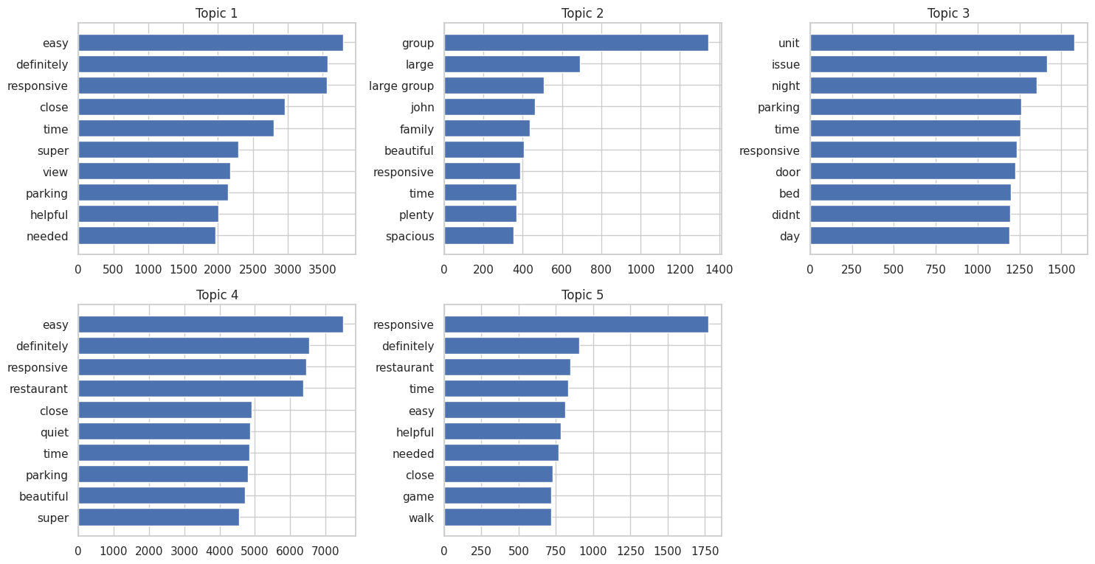
Figure 2: LDA Topic Keywords (Bar Charts)
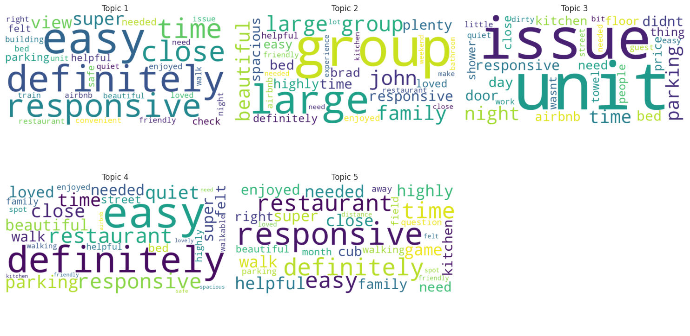
Figure 3: LDA Topic Word Clouds
Topic 1 (Accessibility and Host Responsiveness) was characterized by terms such as "easy," "definitely," "responsive," "close," "view," and "parking," reflecting guest commentary around ease of access, host communication, and proximity to key points of interest.
Topic 2 (Group and Family Stays) was defined by words such as "group," "large," "large group," "family," "spacious," and "plenty," indicating discussions centered on the suitability of listings for larger parties and family travel.
Topic 3 (Property Issues and Overnight Experience) surfaced terms including "unit," "issue," "night," "parking," "bed," "door," and "didnt," suggesting guest accounts of property-level concerns, overnight comfort, and unresolved maintenance or access issues.
Topic 4 (Neighborhood and Dining Proximity) was associated with keywords such as "easy," "restaurant," "quiet," "close," "parking," and "beautiful," pointing to guest experiences related to neighborhood ambiance, walkability, and proximity to dining options.
Topic 5 (Local Exploration and Activities) emerged around terms including "responsive," "restaurant," "walk," "game," "close," and "helpful," reflecting guest experiences tied to local exploration, walkable surroundings, and nearby entertainment venues.
Following topic extraction, the LDA model was used to generate a topic probability distribution for each listing, representing the degree to which each of the five topics was present in that listing's aggregated reviews. These distributions were appended to the dataset as five numeric columns named topic_1 through topic_5, as shown in the sample output. Each row sums to approximately 1, consistent with LDA's probabilistic formulation. These listing-level topic scores were subsequently used as features in the price prediction model to evaluate the influence of latent thematic content on listing valuation.

Non-Negative Matrix Factorization (NMF)
Non-Negative Matrix Factorization was applied to the TF-IDF matrix as a second topic modeling approach. Unlike LDA, which is a probabilistic model, NMF is a linear algebraic technique that decomposes the term-document matrix into two non-negative factor matrices, producing topics with sharper and more interpretable term weights. NMF is particularly effective when applied to TF-IDF representations, as the inverse document frequency weighting helps surface more distinctive and discriminating vocabulary within each topic. The model was configured with five topics and a fixed random state of 1 for reproducibility.
The top 10 keywords extracted from each topic, visualized in Figure 4 as horizontal bar charts and in Figure 5 as word clouds, produced cleaner and more thematically distinct topics compared to LDA:

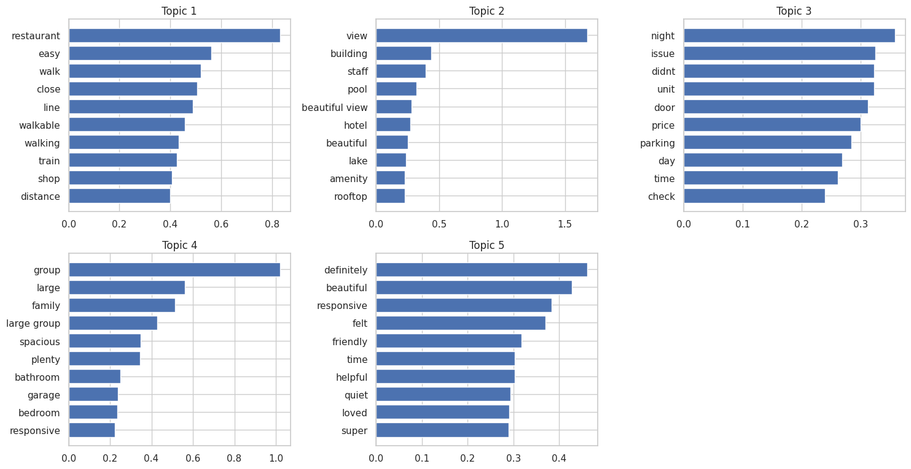
Figure 4: NMF Topic Keywords (Bar Charts)
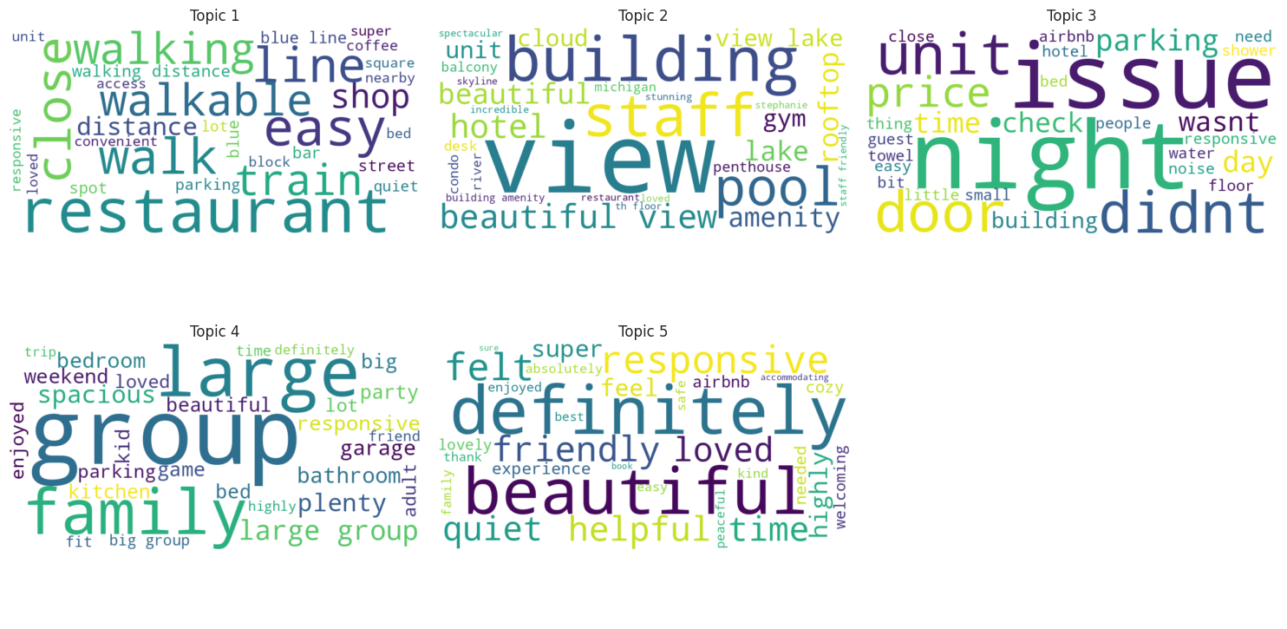
Figure 5: NMF Topic Word Clouds
Topic 1 (Walkability and Local Conveniences) was dominated by terms such as "restaurant," "easy," "walk," "walkable," "line," "train," "shop," and "distance," clearly reflecting guest experiences related to neighborhood walkability, transit accessibility, and proximity to dining and retail options.
Topic 2 (Upscale Property Features and Views) surfaced keywords including "view," "building," "staff," "pool," "beautiful view," "hotel," "lake," "amenity," and "rooftop," indicating guest commentary centered on premium property characteristics, scenic views, and hotel-style amenities.
Topic 3 (Property Issues and Negative Experiences) was characterized by terms such as "night," "issue," "didnt," "unit," "door," "price," "parking," "day," and "check," capturing guest accounts of property-level problems, unmet expectations, and concerns around pricing and check-in procedures.
Topic 4 (Group and Family Accommodations) was defined by words including "group," "large," "family," "large group," "spacious," "plenty," "bathroom," "garage," and "bedroom," clearly representing listings reviewed in the context of group travel and family stays requiring larger and well-equipped spaces.
Topic 5 (Overall Guest Sentiment and Host Quality) emerged around terms such as "definitely," "beautiful," "responsive," "felt," "friendly," "helpful," "quiet," "loved," and "super," reflecting general guest satisfaction, positive host interactions, and the overall emotional tone of the stay experience.
Following topic extraction, the NMF model was used to generate a topic weight distribution for each listing across the five identified topics. These weights were appended to the dataset as columns topic_1 through topic_5 in a dedicated DataFrame named nmf_topics_df. Unlike LDA scores, NMF weights are not constrained to sum to one, and several listings recorded zero weight on certain topics, indicating that those thematic dimensions were not meaningfully represented in their review content. These listing-level NMF topic scores were retained as candidate features for the price prediction model.

Latent Semantic Analysis (LSA)
Latent Semantic Analysis was applied as the third topic modeling approach, implemented via Truncated SVD from scikit-learn. LSA operates by decomposing the term-document matrix into a lower-dimensional latent space that captures underlying semantic relationships between terms and documents, even when different words are used to express similar concepts. Unlike LDA and NMF, LSA does not impose non-negativity constraints, meaning topic scores can take negative values that indicate the relative absence or opposition of a theme within a document. The model was fitted on the Bag-of-Words matrix with five components and a fixed random state of 1.
The top 10 keywords extracted from each topic, visualized in Figure 6 as horizontal bar charts and in Figure 7 as word clouds, yielded the following thematic interpretations:
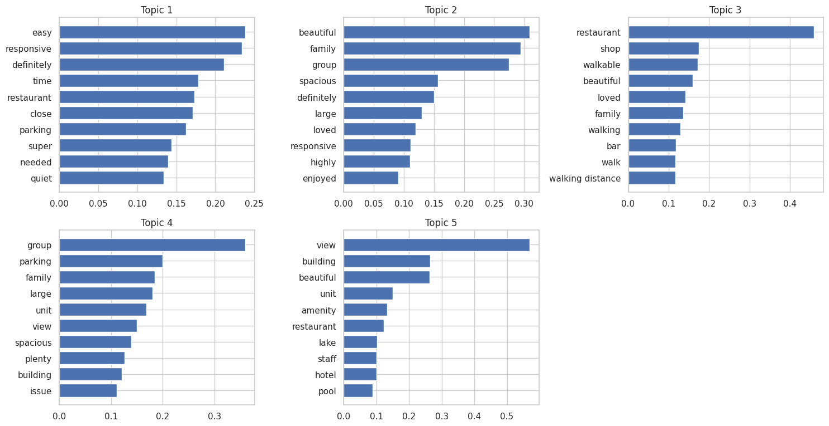
Figure 6: LSA Topic Keywords (Bar Charts)
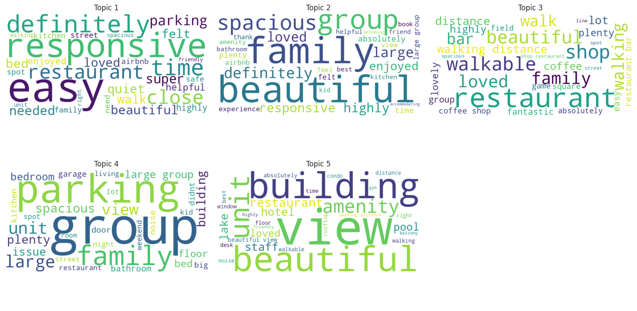
Figure 7: LSA Topic Word Clouds
Topic 1 (Host Responsiveness and General Accessibility) was characterized by terms such as "easy," "responsive," "definitely," "time," "restaurant," "close," "parking," "super," "needed," and "quiet," reflecting broadly positive guest experiences centered on host communication, ease of access, and overall convenience.
Topic 2 (Family and Group Travel Experience) surfaced keywords including "beautiful," "family," "group," "spacious," "definitely," "large," "loved," "responsive," "highly," and "enjoyed," capturing the experiences of guests traveling with family or in groups who valued space, comfort, and positive host interactions.
Topic 3 (Walkability and Neighborhood Amenities) was defined by terms such as "restaurant," "shop," "walkable," "beautiful," "loved," "family," "walking," "bar," "walk," and "walking distance," clearly representing listings praised for their walkable neighborhoods and proximity to local dining, retail, and social venues.
Topic 4 (Larger Property Characteristics and Issues) emerged around keywords including "group," "parking," "family," "large," "unit," "view," "spacious," "plenty," "building," and "issue," reflecting a mixed theme encompassing both the appeal of larger, well-equipped properties and isolated concerns around parking and property-level issues.
Topic 5 (Premium Building Features and Urban Views) was associated with terms such as "view," "building," "beautiful," "unit," "amenity," "restaurant," "lake," "staff," "hotel," and "pool," indicating guest experiences tied to high-end building features, scenic urban and lakefront views, and hotel-style amenities.
Following topic extraction, the LSA model was used to generate component scores for each listing across the five latent dimensions. These scores were stored as columns topic_1 through topic_5 in a dedicated DataFrame named lsa_topics_df. As expected with LSA, scores included both positive and negative values, reflecting the degree and direction of each topic's presence within a listing's review content. These listing-level LSA scores were retained as candidate features for the price prediction model alongside the LDA and NMF topic scores.

Topic Distance Analysis
The PCA-based topic distance plots for all three models are presented in Appendix A (Figures A1, A2, and A3) and reveal notable differences in the structural separation of topics across the three modeling approaches.
The LDA topic distance plot (Figure A1) shows that Topic 1 and Topic 4 are well-separated from the remaining topics along the first principal component, while Topics 2, 3, and 5 cluster together in the lower-left region of the space. This clustering suggests that LDA produced some thematically overlapping topics, particularly among the general accessibility, group travel, and local exploration themes identified earlier.
The NMF topic distance plot (Figure A2) demonstrates a more balanced spread, with Topics 1 and 2 positioned at opposite ends of the first principal component and Topics 3, 4, and 5 forming a loose cluster in the central region. This indicates that NMF achieved stronger separation for its dominant themes, particularly between the walkability and upscale property features topics, while the remaining three topics share some degree of semantic overlap.
The LSA topic distance plot (Figure A3) reveals a pattern where Topic 1 is distinctly isolated at the far right of the PCA space while Topics 2, 3, 4, and 5 are grouped closely together on the left. This concentration suggests that LSA's first component captures the dominant variance in the corpus, leaving the remaining topics with comparatively less discriminating power in the projected two-dimensional space.
Overall, NMF exhibited the most interpretable and structurally balanced topic separation among the three models, reinforcing its suitability as the preferred topic modeling approach for generating listing-level thematic features in the price prediction model.

Modern Topic Modeling with BERTopic
To complement the classical topic modeling approaches, BERTopic was applied as a transformer-based topic modeling method. Unlike LDA, NMF, and LSA, which rely on term frequency statistics and linear algebraic decompositions, BERTopic leverages contextual sentence embeddings generated by pretrained transformer models to cluster semantically similar documents and extract coherent topics. This approach captures richer semantic relationships between words and documents, making it particularly effective for nuanced and informal text such as guest reviews.
The BERTopic model was fitted on the preprocessed review corpus and automatically determined the optimal number of topics from the data. The top word scores for each discovered topic are visualized in Figure 8, revealing a diverse set of thematic clusters spanning non-English vocabulary artifacts, property views and premium amenities, neighborhood-specific experiences, transit and noise concerns, and general guest sentiment themes. Notably, Topic 1 was identified as an outlier topic, which is a standard BERTopic convention for documents that do not fit cleanly into any discovered cluster.
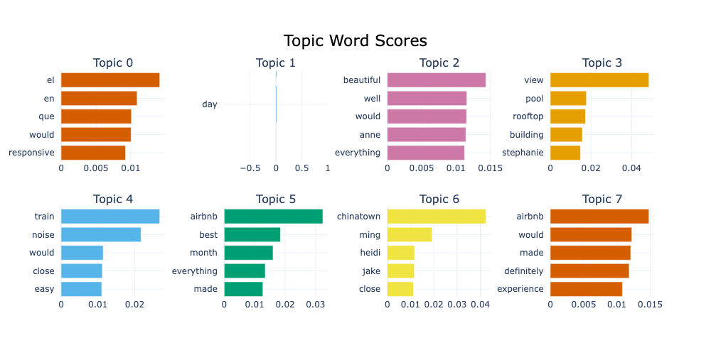
Figure 8: BERTopic Topic Word Scores
Three additional BERTopic diagnostic visualizations including the Hierarchical Clustering dendrogram, the Topic Similarity Matrix, and the Intertopic Distance Map are presented in Appendix B (Figures B1, B2, and B3) for reference.

Initial Exploration of the Listings Dataset
The Listings Dataset was found to contain 8,660 records across 79 columns, encompassing a broad range of structured attributes related to listing characteristics, host profiles, pricing, availability, and guest review scores.
The dataset included a mix of data types, comprising 24 floating-point columns, 20 integer columns, and 35 object columns containing categorical and text-based information. A preliminary inspection of the column-level completeness revealed several fields with notable missing values. The neighbourhood_overview and neighbourhood_group_cleansed columns were among the most incomplete, with the latter containing no non-null values whatsoever and therefore offering no analytical utility. Host-related fields such as host_about, host_location, and host_response_time also exhibited partial missingness, reflecting the optional nature of these profile attributes on the platform. The price column, which serves as the target variable for the prediction model, contained 835 missing entries, reducing its effective coverage to 7,825 records. Review score columns including review_scores_rating, review_scores_cleanliness, and related subcategories were available for 6,976 listings, indicating that approximately 19.4% of listings had not yet accumulated any guest reviews at the time of the snapshot.
Two columns, calendar_updated and neighbourhood_group_cleansed, contained zero non-null values across all 8,660 records and were identified as candidates for removal during the preprocessing stage. These findings established a clear direction for the subsequent data cleaning and feature engineering steps applied to the Listings Dataset prior to model development.

Filtering Listings by Host Location
An inspection of the host_location column revealed that the dataset contained listings managed by hosts located across 212 unique locations spanning cities and countries worldwide, including international locations such as Berlin, Madrid, Dubai, and Manila, as well as numerous cities across the United States outside of Illinois.
Since the objective of this project is specifically focused on the Chicago short-term rental market, the dataset was filtered to retain only those listings where the host location was recorded as "Chicago, IL." This decision ensures that the analysis reflects the experiences and pricing behaviors of locally based hosts who are most representative of the Chicago Airbnb market and whose listings are most likely to reflect genuine local market dynamics.
Following this filtering step, the dataset was reduced from 8,660 records to 5,439 records, retaining the same 79 columns. This subset of locally hosted Chicago listings formed the working dataset for all subsequent preprocessing, feature engineering, and price prediction modeling tasks.

Merging Listings Data with NLP-Derived Features
To enable the integration of guest review insights into the price prediction model, the filtered Listings Dataset was enriched through a series of sequential inner join merge operations with the NLP-derived feature datasets produced during the review analysis phase.
The first merge combined the Listings Dataset with the Hugging Face sentiment results from huggingface_sentiment_reviews_df, joining on the listing identifier to append the transformer-based sentiment score and sentiment label for each listing. The second merge incorporated the zero-shot classification scores from zero_shot_df, adding the five guest experience category scores covering Cleanliness, Safety, Amenities, Location, and Service. The third merge appended the LDA topic probability distributions from lda_topics_df, introducing the five topic score columns representing the latent thematic content of each listing's aggregated reviews. All three merges were performed as inner joins, retaining only listings that appeared in both the Listings Dataset and the respective NLP output, thereby ensuring complete feature availability across all merged columns.
Following these operations, the enriched dataset contained 4,164 records across 96 columns, reflecting the intersection of locally hosted Chicago listings with available NLP-derived review features. This consolidated dataset served as the foundation for all subsequent preprocessing, feature selection, and price prediction model development steps.

Feature Selection
Following the dataset merging step, a focused subset of 24 columns was selected from the enriched dataset to serve as the input features and target variable for the price prediction model. The selected features were organized into six conceptually meaningful groups based on their expected relationship with listing price.
Property Characteristics: The room_type, accommodates, bedrooms, and bathrooms columns were retained as core structural attributes of each listing, capturing the physical capacity and configuration that directly influence pricing decisions.
Location: The latitude and longitude coordinates were included to capture the geographic positioning of each listing within Chicago, allowing the model to implicitly account for neighborhood-level price variation across the city.
Host Quality Signals: The host_is_superhost status and host_acceptance_rate were selected as indicators of host reliability and responsiveness, both of which are known to influence guest booking decisions and by extension the price a host can command.
Review and Rating Signals: The review_scores_rating and number_of_reviews columns were included to capture the perceived quality and market visibility of each listing as reflected through accumulated guest feedback.
Availability and Booking: The availability_365 and instant_bookable fields were retained to account for listing accessibility and booking convenience, both of which influence occupancy and pricing strategy.
NLP-Derived Features: The Hugging Face sentiment score, five zero-shot classification category scores covering Location, Amenities, Service, Cleanliness, and Safety, and five LDA topic scores were included to evaluate the contribution of guest review-derived signals to price prediction accuracy.
The price column was designated as the target variable. The resulting dataset comprised 24 columns and formed the definitive input for all preprocessing and modeling steps that followed.

Data Cleaning and Feature Engineering
Duplicate Check
An initial sanity checks confirmed that the dataset contained no duplicate records, with duplicated().sum() returning zero, ensuring that each listing was represented exactly once in the working dataset.
Type Conversions
Two columns required type conversion before analysis could proceed. The price column was stored as a string with currency formatting, including dollar signs and commas, and was converted to a numeric float by stripping these characters using a regular expression. Similarly, the host_acceptance_rate column was stored as a percentage string and was converted to a float by removing the percentage symbol, making both columns suitable for numerical modeling.
Handling Missing Values
A missing value assessment of the selected 24 columns revealed that five columns contained null entries: price (324 missing), bathrooms (314 missing), host_is_superhost (157 missing), host_acceptance_rate (106 missing), and bedrooms (99 missing). All remaining columns were complete.
Rows with missing values in the price column were removed first, as price is the target variable and imputation would introduce bias into the model. Following this step, the bathrooms missingness was fully resolved, reducing to zero null entries. The remaining five missing bedrooms values were imputed using the column median to preserve distributional characteristics without introducing extreme values. Missing host_is_superhost values were filled using the column mode, as this is a binary categorical field where the most frequent value represents the most likely status. Finally, missing host_acceptance_rate values were imputed using the median acceptance rate grouped by superhost status, ensuring that the imputed values reflected realistic acceptance rate patterns for each host category.
Following all cleaning operations, the dataset contained no remaining missing values and was reduced to a final shape of 3,840 records across 24 columns, ready for exploratory analysis and model development.

Exploratory Data Analysis (EDA)
Descriptive statistics were computed separately for numerical and categorical columns to develop a comprehensive understanding of the distribution and characteristics of the cleaned dataset prior to modeling.
Numerical Features
The target variable price exhibited a mean of $192.40 with a standard deviation of $190.33, indicating considerable variability in listing prices across the Chicago market. The minimum recorded price was $20.00 and the maximum was $4,500.00, with a median of $144.00, suggesting a right-skewed distribution driven by a relatively small number of premium or luxury listings. The interquartile range spanned from $97.00 to $227.25, representing the core pricing band for most listings.
The accommodates variable ranged from 1 to 16 guests with a mean of approximately 5, while bedrooms averaged 1.98 and bathrooms averaged 1.49, reflecting a dataset predominantly composed of mid-sized residential properties. The host_acceptance_rate was notably high, with a mean of 93.02% and a median of 98%, indicating that most Chicago hosts maintain highly accommodating booking practices. The review_scores_rating was tightly distributed between 1.00 and 5.00 with a mean of 4.81 and a 75th percentile of 4.97, confirming the strongly positive review landscape identified during the NLP analysis. The number_of_reviews was highly right-skewed, with a median of 48 but a maximum of 905, reflecting the presence of a small number of exceptionally active listings. The availability_365 field showed a mean of 231.56 days, suggesting that most listings maintain substantial annual availability.
Among the NLP-derived features, the zero-shot classification scores for Location, Amenities, Service, Cleanliness, and Safety all showed high median values above 0.99, consistent with the earlier observation that aggregated reviews contain sufficient thematic content across all five guest experience dimensions. The LDA topic scores showed greater variability, with topic_4 recording the highest mean of 0.45, reinforcing its dominance as the most prevalent topic across the corpus.
Categorical Features
Among the three categorical columns, room_type contained 4 unique categories with "Entire home/apt" being the most frequent, appearing in 3,111 of the 3,840 listings and representing approximately 81% of the dataset. The host_is_superhost field showed that most hosts held superhost status, with 2,487 listings associated with superhost designation. The instant_bookable field revealed that 2,721 listings, representing approximately 71% of the dataset, did not offer instant booking, indicating that most Chicago hosts prefer to review booking requests manually before confirming reservations.
Univariate Analysis
Figure 9 presents the distribution of all numerical features in the cleaned dataset, providing insight into the shape, spread, and skewness of each variable prior to modeling.
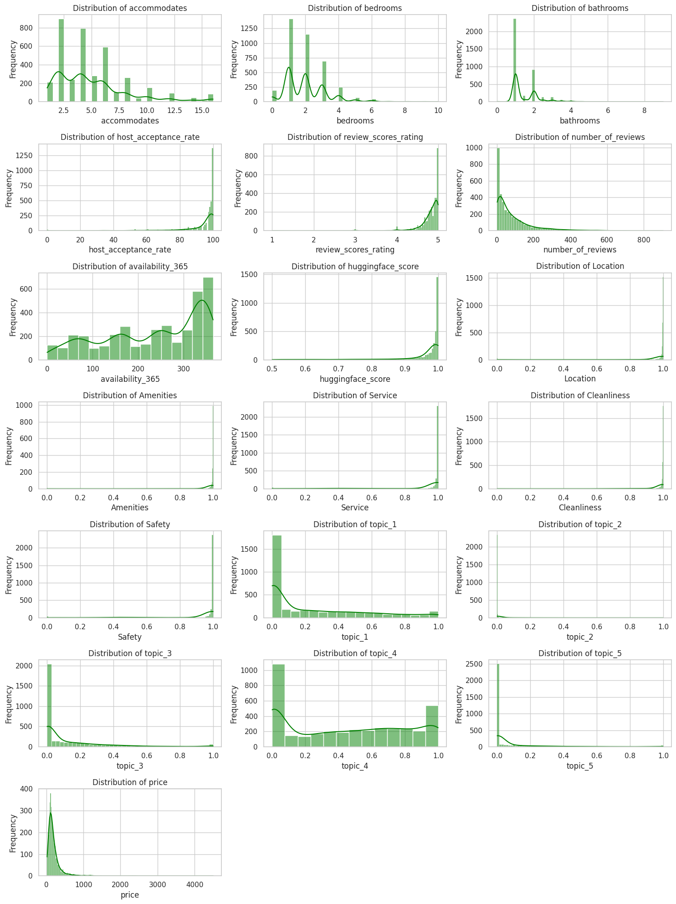
Figure 9: Distribution of Numerical Features
Property Characteristics: The accommodates distribution is multimodal, with notable peaks at 2, 4, and 6 guests, reflecting the prevalence of listings designed for small to medium-sized groups. The bedrooms distribution is strongly right-skewed, with most listings containing 1 to 2 bedrooms and a long tail extending to 10 bedrooms. The bathrooms distribution follows a similar pattern, with most listings offering 1 bathroom and a sharp decline in frequency for higher counts.
Host and Review Features: The host_acceptance_rate distribution is heavily left-skewed, with a large concentration of hosts maintaining acceptance rates between 90% and 100%, confirming the high acceptance rates observed in the descriptive statistics. The review_scores_rating distribution is strongly left-skewed, with most listings clustered near the maximum score of 5.0, consistent with the positive sentiment patterns identified during the NLP analysis. The number_of_reviews distribution is highly right-skewed, with most listings having fewer than 100 reviews and a small number of outlier listings exceeding 500 reviews.
Availability: The availability_365 distribution is relatively uniform with a slight uptick at the upper end, indicating that a meaningful portion of listings maintain near-full annual availability, likely corresponding to professionally managed properties.
NLP-Derived Features: The Hugging Face sentiment score is strongly left-skewed, with most listings scoring above 0.90, consistent with the predominantly positive sentiment classification results. The zero-shot classification scores for Location, Amenities, Service, Cleanliness, and Safety all exhibit pronounced left-skewed distributions, with most values concentrated near 1.0, reflecting the high thematic relevance of aggregated review text across all five guest experience dimensions. Among the LDA topic scores, topic_1 and topic_4 show more uniform distributions across the 0 to 1 range, while topic_2, topic_3, and topic_5 are heavily right-skewed, with most listings recording near-zero probability for these topics, indicating that they represent more specialized themes present in only a subset of listings.
Target Variable: The price distribution is strongly right-skewed, with most listings priced below $500 per night and a long tail extending to $4,500. This skewness indicated the necessity of a log transformation of the target variable prior to model training to normalize its distribution and improve model performance.
Figure 10 presents boxplots for all numerical features, providing a visual assessment of the spread, central tendency, and presence of outliers across the dataset.
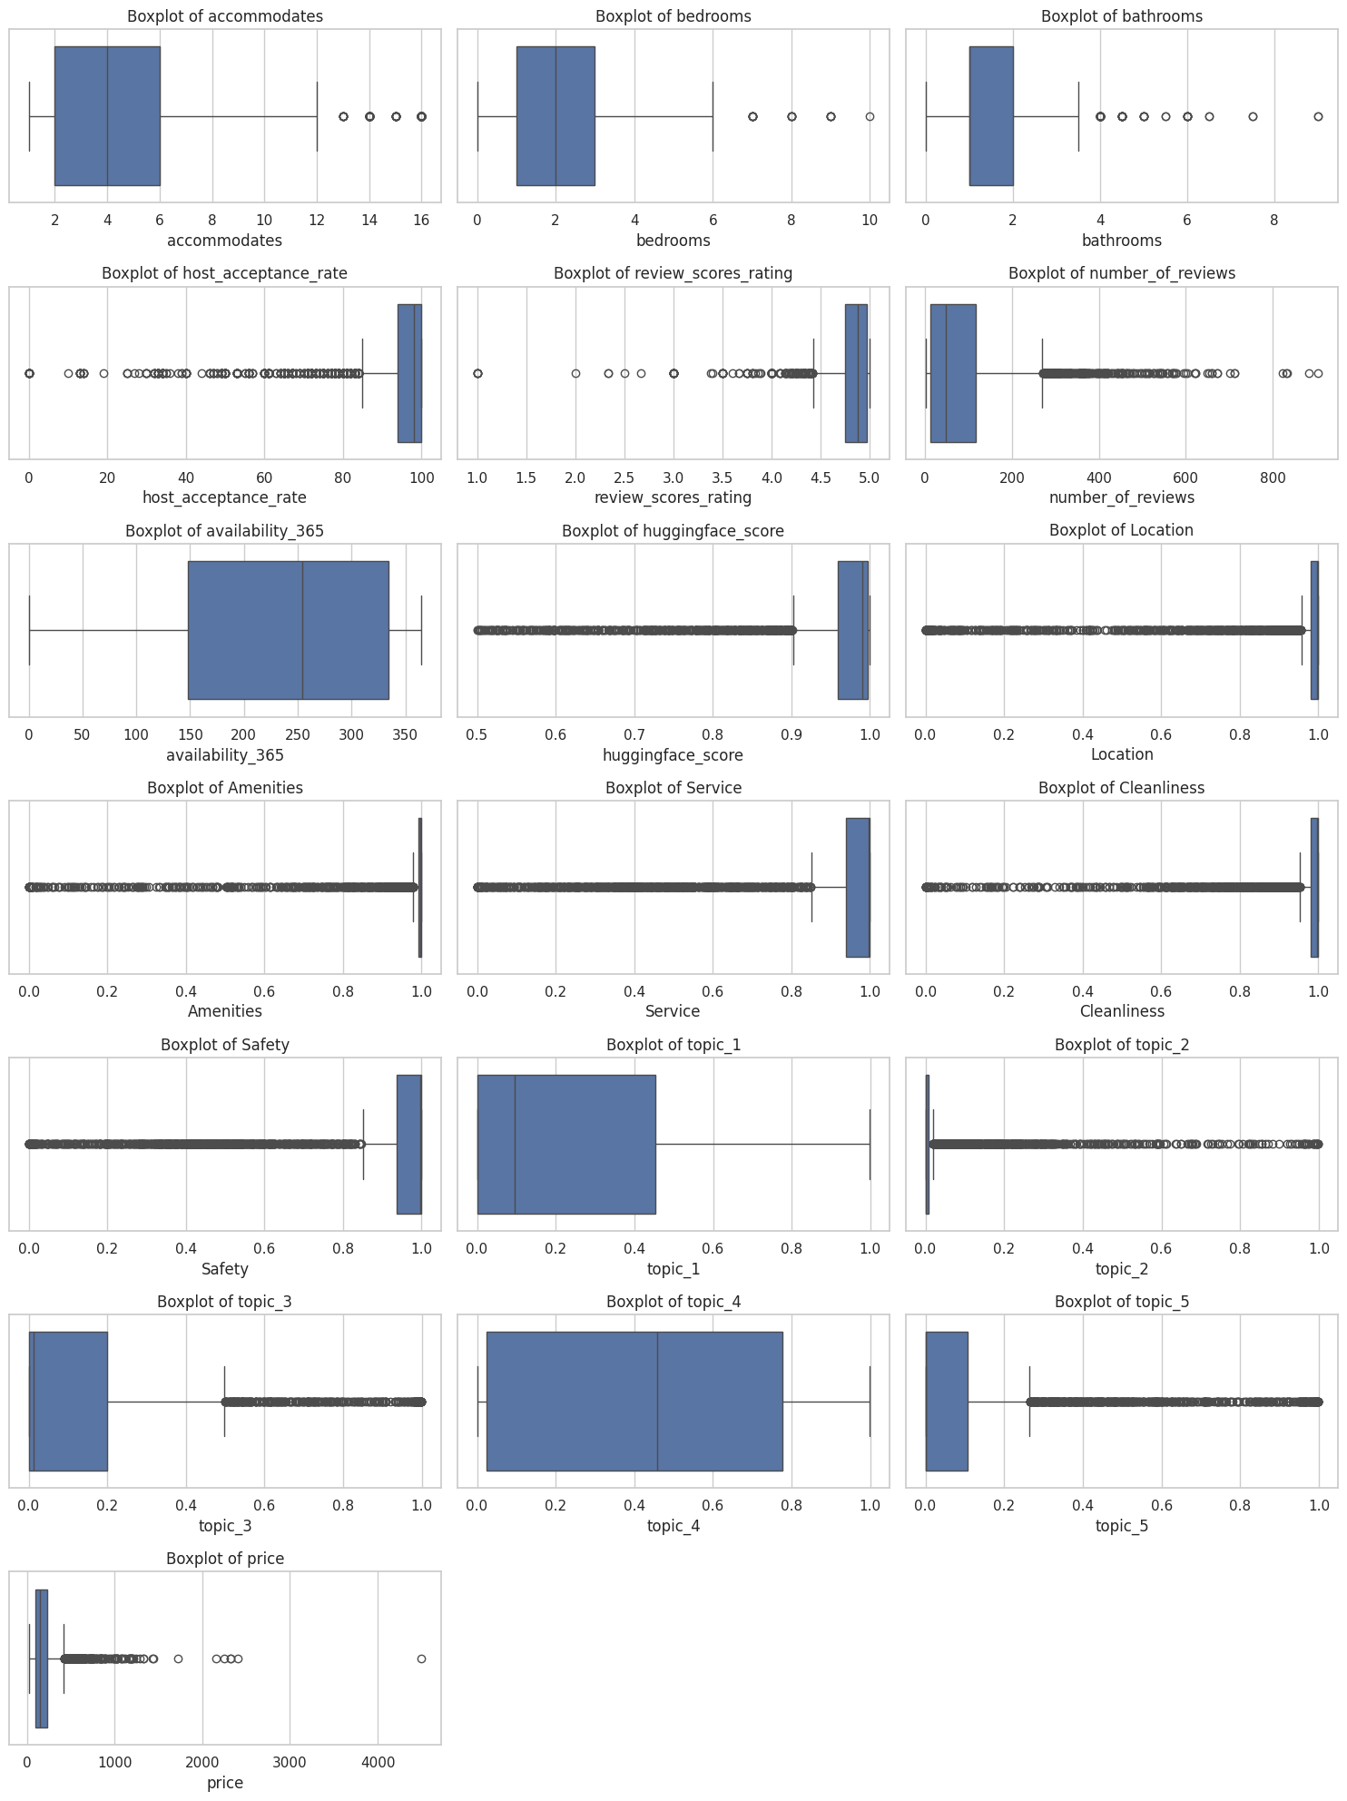
Figure 10: Boxplots of Numerical Features
Property Characteristics: The accommodates, bedrooms, and bathrooms features all exhibit right-skewed distributions with a small number of high-value outliers, corresponding to large properties capable of hosting considerably more guests than the typical listing. These outliers are legitimate data points representing genuinely larger properties rather than data entry errors and were therefore retained.
Host and Review Features: The host_acceptance_rate boxplot reveals a cluster of low-value outliers on the left tail, representing a small number of hosts with unusually restrictive booking practices relative to the predominantly high acceptance rates observed across the dataset. The review_scores_rating boxplot shows a compact interquartile range near the upper end of the scale, with a small number of low-scoring outliers extending toward 1.0, reflecting the rare occurrence of poorly rated listings in an otherwise highly rated market. The number_of_reviews distribution is heavily right-skewed with numerous high-value outliers, confirming the presence of a small cohort of exceptionally active listings with review counts far exceeding the dataset median.
NLP-Derived Features: The Hugging Face sentiment score and all five zero-shot classification scores display a consistent pattern of low-value outliers, reflecting listings whose aggregated review text scored unexpectedly low on one or more guest experience dimensions. Among the LDA topic scores, topic_1 and topic_4 exhibit wide interquartile ranges indicating genuine variability in topic prevalence, while topic_2, topic_3, and topic_5 are characterized by compact boxes with numerous high-value outliers, confirming that these topics are concentrated in a small subset of listings.
Target Variable: The price boxplot confirms the strong right skew observed in the histogram, with a compact interquartile range between approximately $97 and $227 and several high-value outliers extending up to $4,500. These extreme values represent luxury or large-group listings and, while genuine, contribute to the non-normal distribution of the target variable, reinforcing the decision to apply a log transformation prior to model training.
Figure 11 presents count plots for the three categorical features in the dataset, illustrating the frequency distribution of each category across the 3,840 listings.
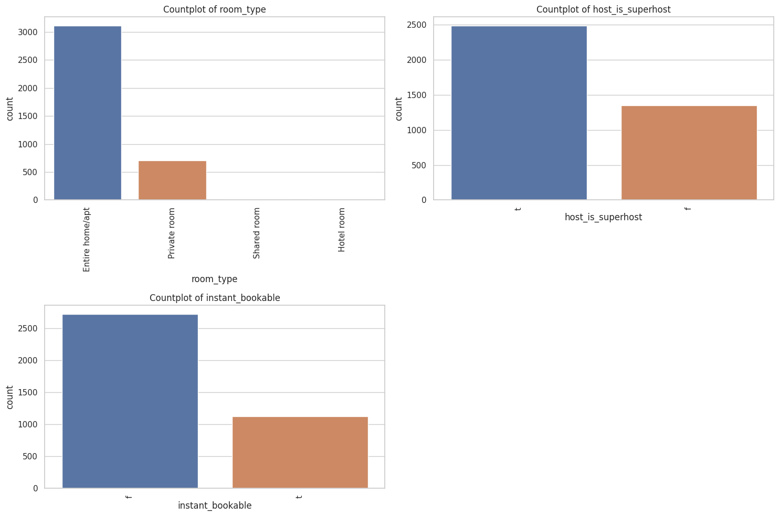
Figure 11: Count Plots of Categorical Features
Room Type: The room_type distribution is heavily dominated by "Entire home/apt" listings, which account for approximately 3,111 listings, representing over 80% of the dataset. "Private room" is the second most common category with approximately 670 listings, while "Shared room" and "Hotel room" are negligibly represented, indicating that the Chicago Airbnb market is overwhelmingly oriented toward whole-property rentals rather than shared or hotel-style accommodations.
Host Superhost Status: The host_is_superhost distribution shows that approximately 2,487 listings, representing roughly 65% of the dataset, are managed by hosts who have attained superhost status. This relatively high proportion of superhosts within the locally filtered Chicago dataset reflects the tendency of dedicated and experienced local hosts to maintain the high standards required for superhost designation, including strong response rates, high acceptance rates, and consistently positive guest reviews.
Instant Bookable: The instant_bookable distribution reveals that approximately 2,650 listings do not offer instant booking, representing around 69% of the dataset, while the remaining 1,090 listings allow guests to book immediately without host approval. This pattern suggests that most Chicago hosts prefer to retain control over guest selection by reviewing booking requests manually before confirming reservations, which may reflect a preference for more selective hosting practices among locally based hosts.

Bivariate Analysis
Figure 12 presents a pairwise scatter plot matrix across all numerical features in the dataset, enabling a simultaneous visual assessment of bivariate relationships, distributional shapes, and potential correlations between variables.
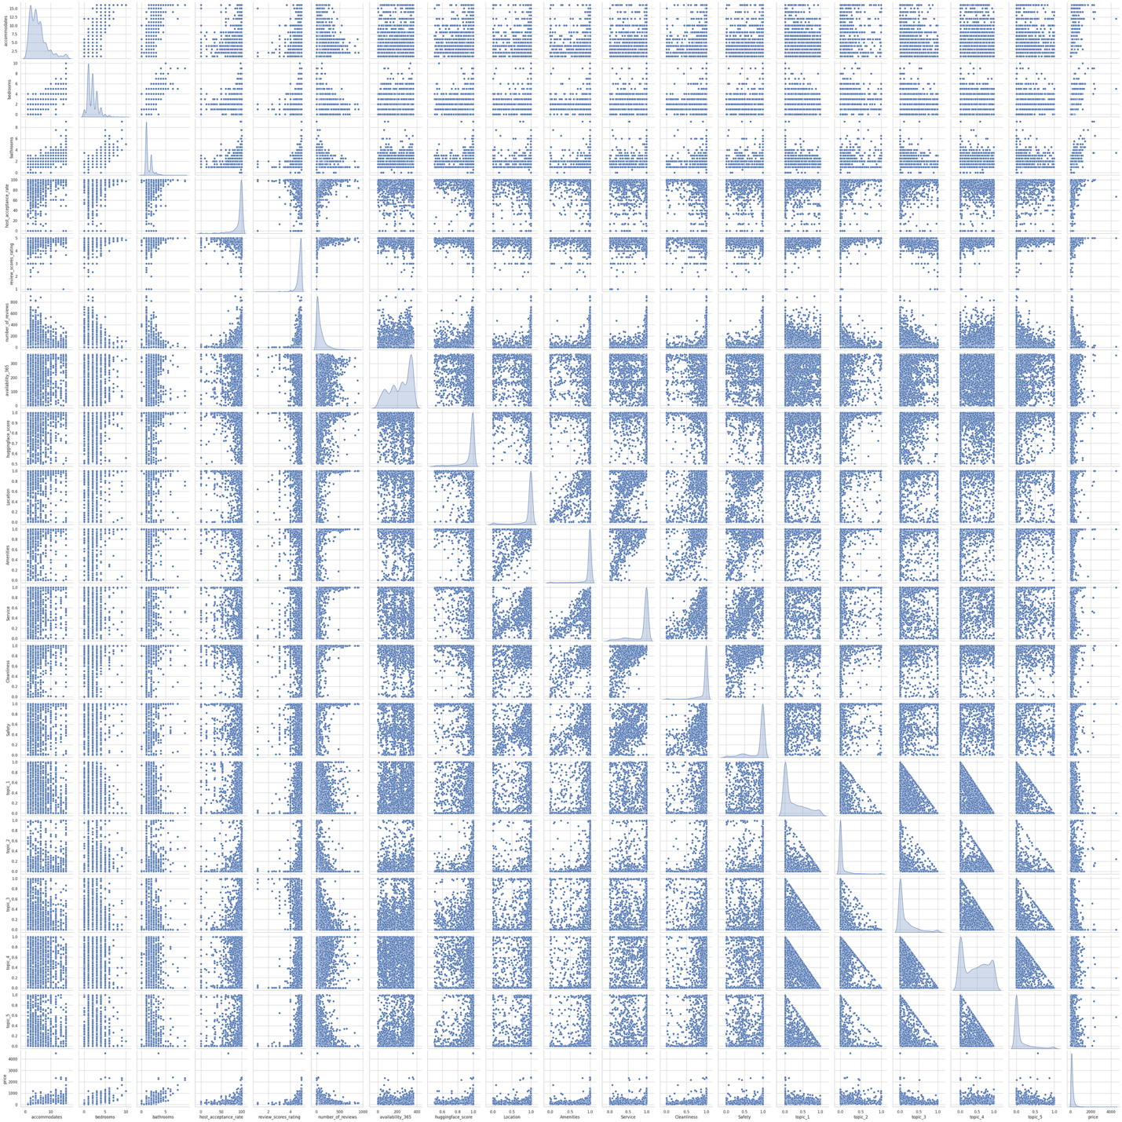
Figure 12: Pairwise Scatter Plot Matrix
The diagonal of the matrix displays the marginal distribution of each feature, confirming the distributional characteristics observed in the univariate analysis, including the right-skewed nature of price, number_of_reviews, and the LDA topic scores, as well as the left-skewed concentration of the zero-shot classification scores and review_scores_rating near their upper bounds.
Among the structural property features, accommodates, bedrooms, and bathrooms exhibit clear positive associations with one another, as expected given their shared dependence on the physical size and capacity of a listing. These features also show a visible positive relationship with price, with larger listings commanding higher nightly rates. The scatter plots between price and accommodates and between price and bedrooms in particular reveal an upward trend, confirming that property size is a meaningful determinant of listing price.
The geographic coordinates latitude and longitude show no clear linear relationship with price individually, though their combined spatial signal may still contribute predictive value to the model when interpreted together.
The NLP-derived features including the Hugging Face sentiment score and the five zero-shot classification scores do not exhibit strong visual linear relationships with price in the scatter plots, suggesting that their contribution to price prediction may be modest or indirect. The LDA topic scores similarly show diffuse scatter patterns against the target variable, consistent with the probabilistic and distributional nature of topic representations. These observations motivate a more rigorous evaluation of feature importance within the modeling framework to quantify the actual predictive contribution of each NLP-derived variable.
Figure 13 presents individual scatter plots of each numerical feature against the target variable price, providing a clearer view of the directional relationships between predictors and listing price.
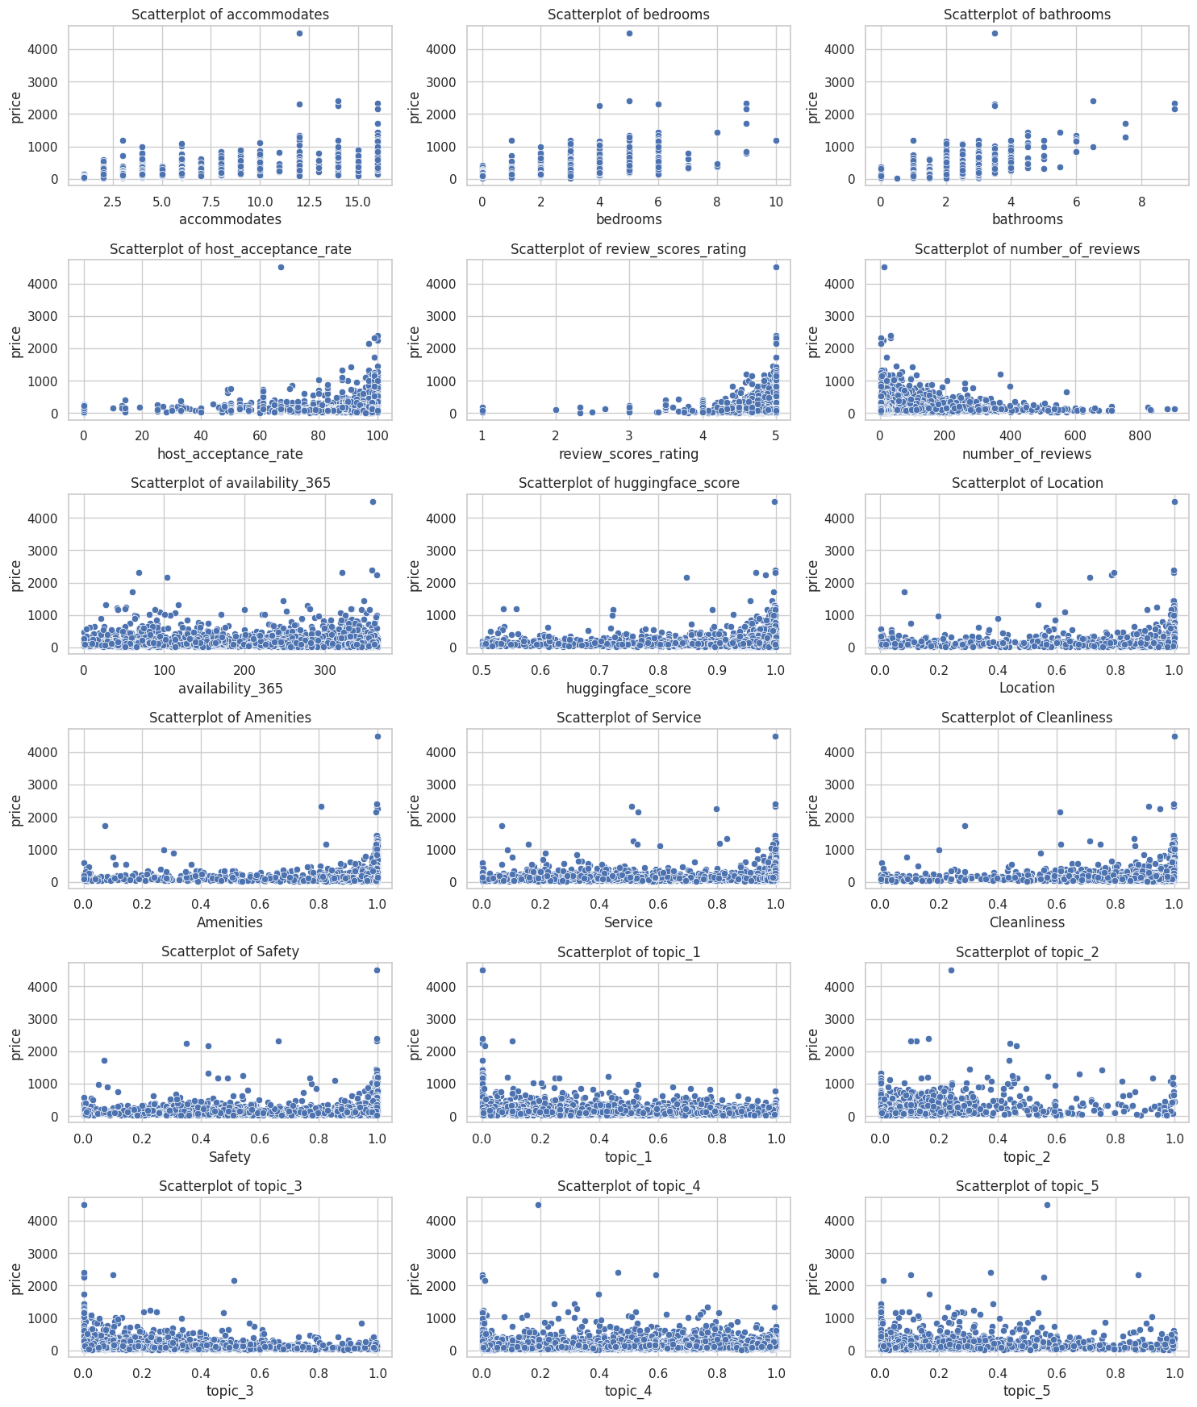
Figure 13: Scatter Plots of Features Against Price
Property Characteristics: The scatter plots for accommodates, bedrooms, and bathrooms all display a visible positive relationship with price, where listings with greater capacity and more rooms tend to command higher nightly rates. While the relationships are not strictly linear due to the presence of high-value outliers, the general upward trend confirms that property size is among the strongest structural determinants of listing price in the Chicago market.
Host and Review Features: The host_acceptance_rate scatter plot shows a diffuse pattern with no clear directional trend, suggesting that acceptance rate alone has limited direct influence on price. The review_scores_rating scatter plot reveals that the highest-priced listings are concentrated at ratings close to 5.0, though the relationship is not strongly linear given the narrow range within which most ratings fall. The number_of_reviews scatter plot shows no meaningful linear relationship with price, with high-priced listings distributed across all review count levels.
Availability: The availability_365 scatter plot shows a scattered and relatively flat pattern against price, indicating that annual availability does not directly predict listing price in a consistent manner across the dataset.
NLP-Derived Features: The scatter plots for the Hugging Face sentiment score and all five zero-shot classification scores for Location, Amenities, Service, Cleanliness, and Safety display a consistent pattern where the highest-priced listings are concentrated at scores approaching 1.0. However, given that most listings already score near 1.0 on these dimensions, the discriminating power of these features in price prediction is limited when considered in isolation. The LDA topic scores across topic_1 through topic_5 similarly show diffuse scatter patterns with no strong directional relationship to price, though isolated high-price observations appear across the full range of topic scores for each dimension. These findings suggest that NLP-derived features are likely to contribute modestly to price prediction when combined with structural features within a regression framework rather than acting as standalone predictors.
Figure 14 presents boxplots of listing price across each of the three categorical features, providing insight into how room type, superhost status, and instant bookability relate to pricing levels in the Chicago Airbnb market.
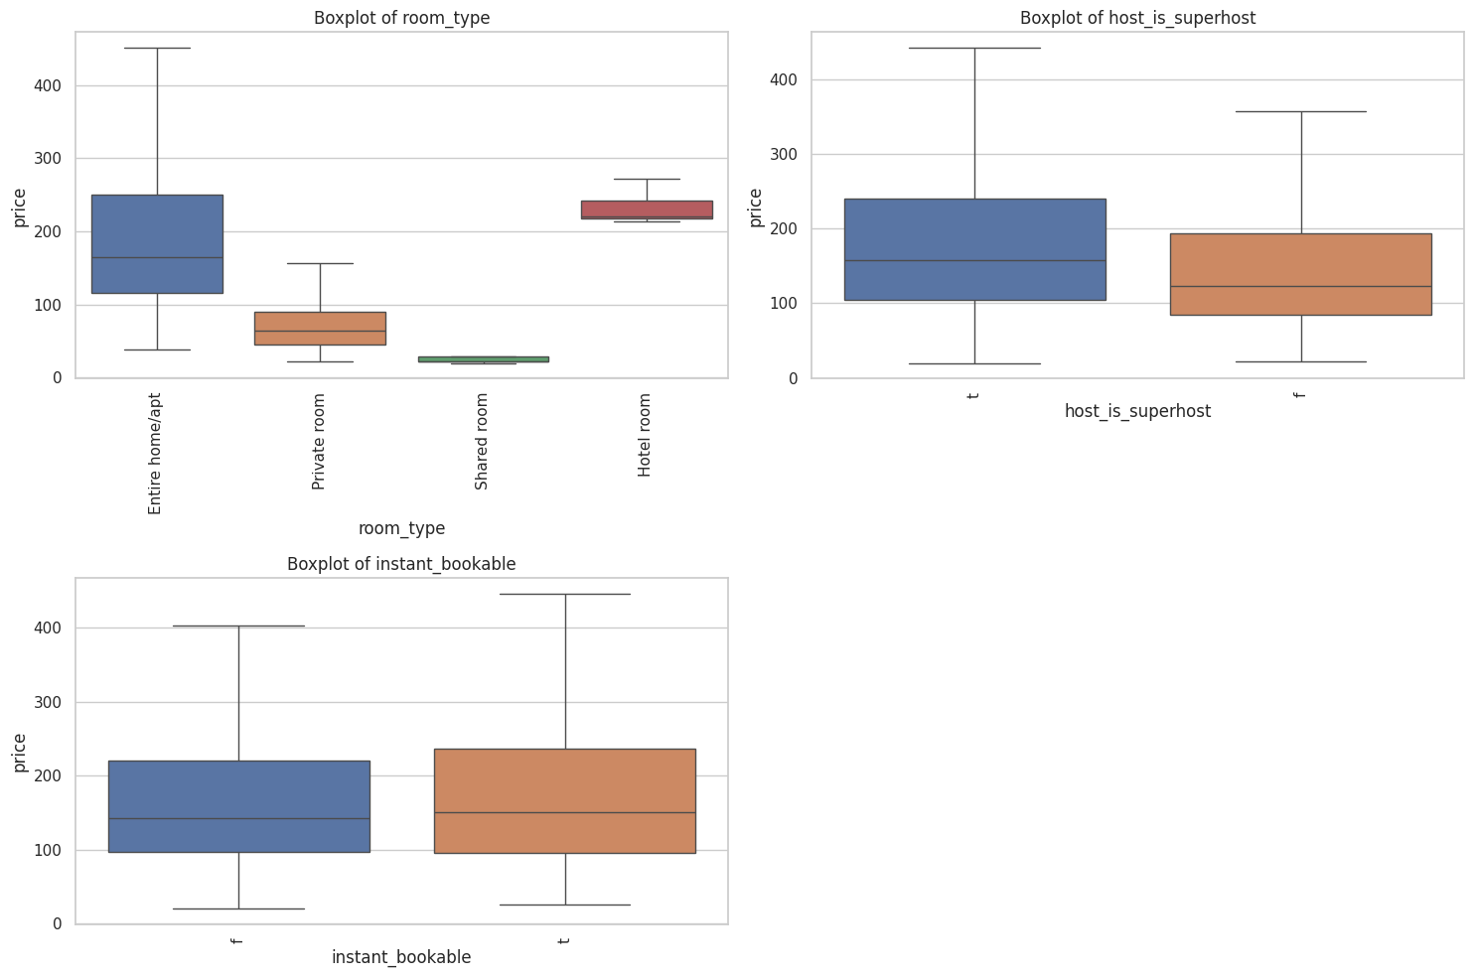
Figure 14: Boxplots of Categorical Features Against Price
Room Type: The room_type boxplot reveals the most pronounced price differentiation among the categorical features. "Entire home/apt" listings command the highest median price of approximately $175, with a wide interquartile range reflecting the diversity of whole-property listings across different sizes and neighborhoods. "Hotel room" listings show a comparably high and compact price range centered around $235, likely reflecting the standardized pricing practices of professionally managed hotel-style accommodations. "Private room" listings are priced considerably lower, with a median near $70, consistent with the expectation that guests paying for a shared property receive fewer amenities and less privacy. "Shared room" listings record the lowest prices in the dataset, with a very narrow and compressed price range close to $20, reflecting the budget nature of this accommodation type.
Host Superhost Status: Superhosts command a modestly higher median price compared to non-superhosts, with their interquartile range spanning approximately $100 to $240 against a range of roughly $75 to $195 for non-superhosts. This suggests that superhost designation is associated with a moderate price premium, likely reflecting the higher perceived quality and trustworthiness that guests attribute to these hosts.
Instant Bookable: The price distributions for instantly bookable and non-instantly bookable listings are broadly similar, with comparable medians near $150 and overlapping interquartile ranges. This indicates that the instant booking feature does not meaningfully differentiate listing prices in the Chicago market and is unlikely to be a strong predictor of price within the modeling framework.

Correlation Analysis
Figure 15 presents a Pearson correlation heatmap across all numerical features, quantifying the linear relationships between variables and providing a structured basis for understanding feature interdependencies and their association with the target variable.
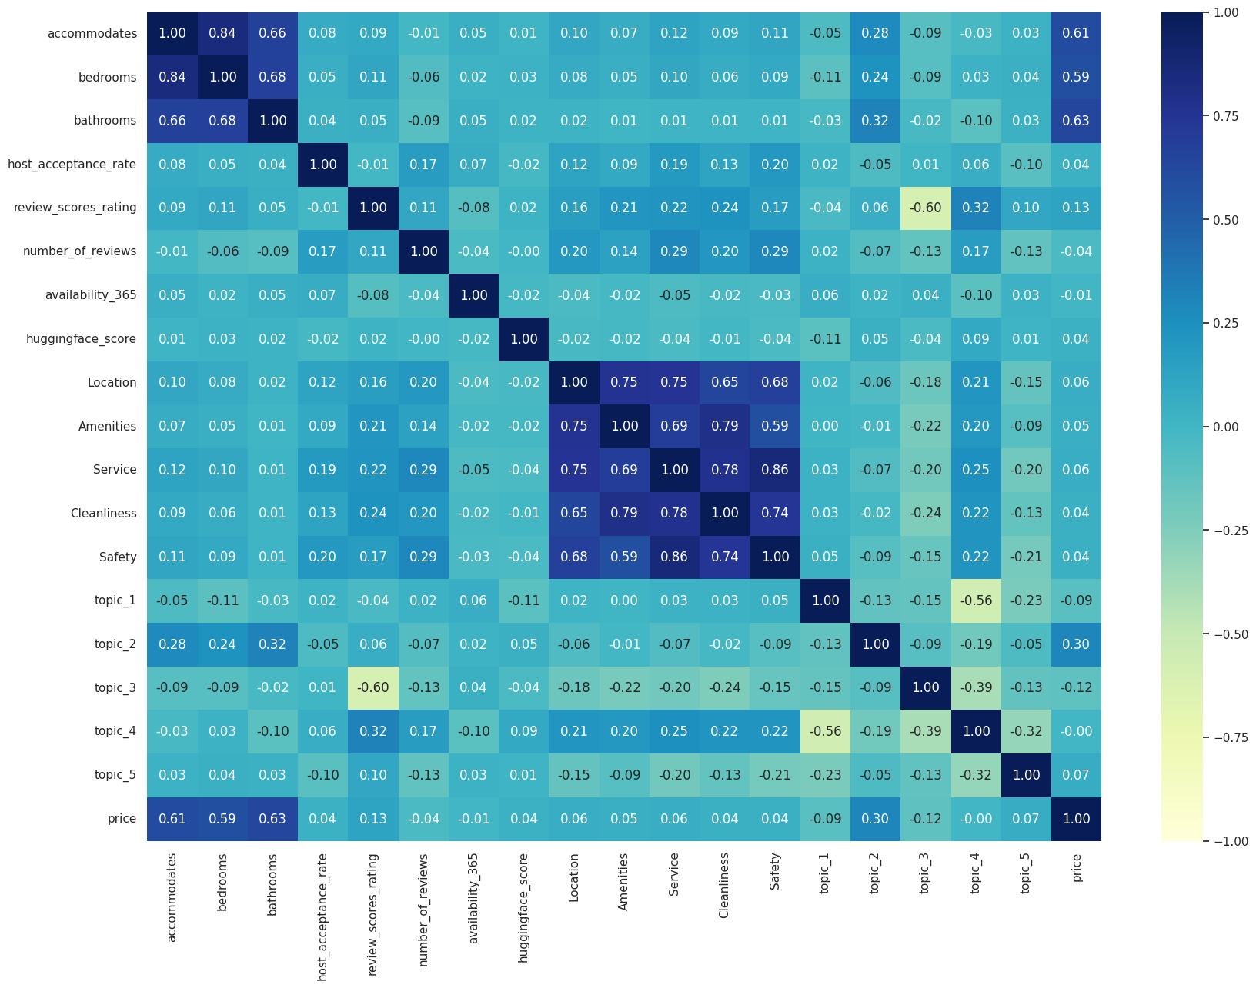
Figure 15: Pearson Correlation Heatmap
Correlations with Price: The three property size features demonstrated the strongest correlations with price, with bathrooms recording the highest correlation of 0.63, followed by accommodates at 0.61 and bedrooms at 0.59. These findings confirm that physical property capacity is the primary structural determinant of listing price in the Chicago market. The topic_2 LDA score showed a moderate positive correlation with price of 0.30, suggesting that listings associated with the upscale property features and views theme tend to command higher prices. The review_scores_rating showed a modest positive correlation of 0.13, while number_of_reviews and availability_365 showed negligible correlations of 0.04 and 0.01 respectively, indicating limited direct linear influence on price. The NLP-derived zero-shot classification scores for Location, Amenities, Service, Cleanliness, and Safety all recorded weak correlations with price ranging between 0.04 and 0.06, consistent with the scatter plot observations.
Intercorrelations Among Features: The zero-shot classification scores exhibited strong intercorrelations with one another, with Service and Safety recording the highest pairwise correlation of 0.86, followed by Amenities and Cleanliness at 0.79 and Location and Amenities at 0.75. This high degree of multicollinearity among the zero-shot features suggests that these five dimensions capture overlapping aspects of guest experience and may not contribute independently to price prediction. Among the property size features, accommodates and bedrooms were strongly correlated at 0.84, and bedrooms and bathrooms at 0.68. The LDA topic scores showed notable intercorrelations as well, with topic_3 and review_scores_rating recording a strong negative correlation of 0.60 and topic_3 and topic_4 recording a correlation of 0.39, indicating that listings associated with property issues tend to receive lower review ratings. These multicollinearity patterns were noted as important considerations for model design and feature interpretation.

Geographic Distribution of Listings by Price Range
The geographic distribution of Chicago Airbnb listings, color-coded by price range, is presented in Appendix C (Figure C1). Listings were categorized into four price bands: below $100, $100 to $200, $200 to $300, and above $300 per night, and plotted on an interactive OpenStreetMap base layer using their recorded latitude and longitude coordinates.
The map reveals a clear spatial concentration of listings along Chicago's eastern lakefront corridor, spanning from the downtown Loop area northward through neighborhoods such as Lincoln Park, Lakeview, and Wicker Park. This geographic clustering is consistent with the high demand for short-term rentals in areas offering proximity to Lake Michigan, major tourist attractions, dining, and entertainment districts.
In terms of price distribution, the mid-range listings priced between $100 and $200 dominate the map across most neighborhoods, forming the densest cluster of activity. Higher-priced listings exceeding $300 per night are most visibly concentrated in and around the downtown core and the near-north lakefront neighborhoods, reflecting the premium commanded by centrally located properties with scenic views and convenient access to Chicago's primary commercial and cultural destinations. Budget listings priced below $100 are more dispersed across the map and appear with greater frequency in neighborhoods further from the lakefront and downtown core, suggesting that geographic proximity to key attractions is a meaningful spatial driver of listing price in the Chicago market.

Data Pre-Processing

Handling Outliers of Independent Variables
Outlier detection was performed across all numerical columns using the Interquartile Range (IQR) method, where the lower bound was defined as Q1 minus 1.5 times the IQR and the upper bound as Q3 plus 1.5 times the IQR. The percentage of outliers identified in each column varied considerably, with the NLP-derived features recording the highest outlier rates. Specifically, Service recorded 22.11%, Safety recorded 21.90%, topic_2 recorded 21.12%, Location recorded 19.51%, and Cleanliness recorded 19.45%. Among the structural features, host_acceptance_rate recorded an outlier rate of 12.86%, number_of_reviews recorded 6.82%, review_scores_rating recorded 5.13%, and price recorded 6.67%.
Selective Outlier Treatment
Not all detected outliers were treated, as many extreme values represented valid and meaningful listing characteristics rather than data errors. The following considerations guided the selective treatment strategy:
Property size features including accommodates, bedrooms, and bathrooms were retained without modification, as high values legitimately represent large homes and group accommodations whose removal would eliminate important premium property information. The NLP-derived features including the Hugging Face sentiment score, zero-shot classification scores, and LDA topic scores were also retained in full, as these are bounded confidence and probability scores where both low and high values carry genuine analytical meaning. The availability_365 field was excluded from outlier treatment since values from 0 to 365 are all naturally valid. Geographic coordinates latitude and longitude were similarly excluded, as modifying them would distort the actual spatial location of listings.
IQR-based capping, also known as Winsorization, was applied selectively to host_acceptance_rate, review_scores_rating, and number_of_reviews, as these features exhibited clear distributional skewness that could bias model learning without requiring the removal of records. Values falling below the lower bound were capped at the lower bound and values exceeding the upper bound were capped at the upper bound, preserving the full dataset size while constraining the influence of extreme observations.
Handling Outliers in the Target Variable
The price column was treated separately given its role as the target variable, where extreme values can disproportionately distort regression model training. As shown in Figure 16, the price distribution before treatment exhibited a pronounced right-skewed tail extending to $4,500, with most listings concentrated below $500. Listings priced above the 99th percentile threshold were removed to reduce target distortion while preserving 99% of the dataset. Following this step, the price distribution shown in Figure 17 remained right-skewed but with a substantially reduced upper tail, capping the effective price range at approximately $900 and providing a more representative distribution for model training.
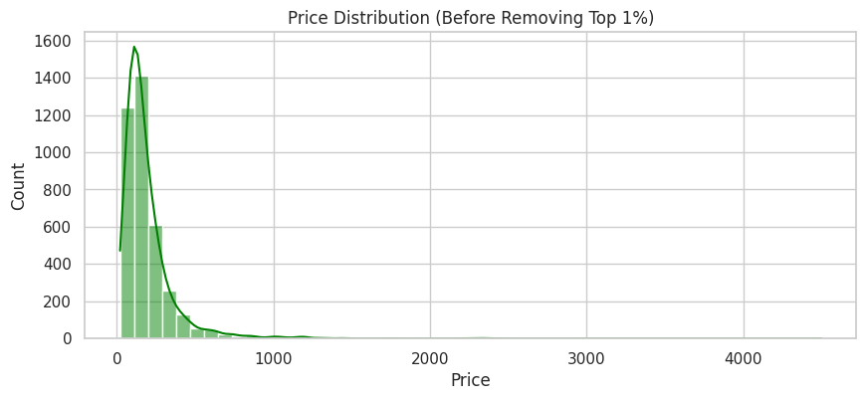
Figure 16: Price Distribution Before Removing Top 1%
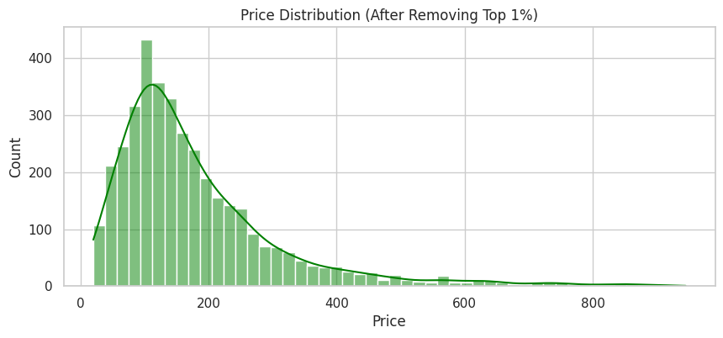
Figure 17: Price Distribution After Removing Top 1%

Encoding Categorical Variables
Binary Mapping of Boolean-Like Columns
The host_is_superhost and instant_bookable columns were originally stored as categorical Boolean-like values using the string characters "t" and "f" to denote true and false respectively. Since neural network and machine learning models require numerical inputs, these columns were converted to binary integer format by mapping "t" to 1 and "f" to 0. Binary mapping was chosen over one-hot encoding for these two columns because each contains only two possible categories, making a single binary indicator sufficient to fully represent the information without introducing redundant dimensions. This transformation preserved the semantic meaning of both features while making them directly usable as numerical inputs in the price prediction model.
One-Hot Encoding of Room Type
The room_type column contained four distinct categorical values and was converted into numerical dummy variables using pd.get_dummies() with the drop_first=True parameter, which drops the first category to avoid multicollinearity among the encoded columns. This produced three binary indicator columns representing Private room, Shared room, and Hotel room, with Entire home/apt serving as the implicit reference category. The auxiliary price_range column created during the geographic visualization step was subsequently dropped as it was no longer required for modeling. All remaining columns were cast to float data type to ensure full compatibility with the neural network and machine learning model frameworks used in the subsequent modeling phase.

Data Preparation for Model Building
Feature and Target Separation
The dataset was split into an independent feature matrix and a target variable vector prior to model training. The price column was assigned as the target variable y, while latitude and longitude were dropped from the feature matrix X alongside price. Although geographic coordinates were retained through the exploratory analysis phase, they were excluded from the modeling feature set to avoid introducing high-cardinality spatial noise into the regression framework, as the model was not designed to explicitly learn location-based price effects from raw coordinate values.
Train-Test Split
The dataset was partitioned into training and testing sets using a 70/30 split with a fixed random state of 1 to ensure reproducibility. The resulting training set contained 2,660 records across 23 features and the testing set contained 1,141 records across 23 features, providing a sufficiently large held-out evaluation set to reliably assess model generalization performance on unseen data.
Feature Normalization
A Keras Normalization layer was initialized and adapted to the training feature matrix prior to model construction. This layer computes the mean and variance of each feature from the training data and applies standardization during the forward pass, transforming all input features to have approximately zero mean and unit variance. Fitting the normalization layer exclusively on the training set ensures that no information from the test set leaks into the preprocessing step, maintaining the integrity of the model evaluation. The adapted normalization layer was subsequently incorporated as the first layer of the neural network architecture to ensure consistent feature scaling during both training and inference.

Building Neural Network Regression Models using Keras Sequential and XGBoost Model

Neural Network Model 1: Baseline Architecture
Model Architecture
The first neural network model was constructed using the Keras Sequential API as a baseline regression model to predict Airbnb listing prices. The architecture, illustrated in Figure 18, consisted of a normalization input layer followed by three fully connected hidden layers and a single output neuron.
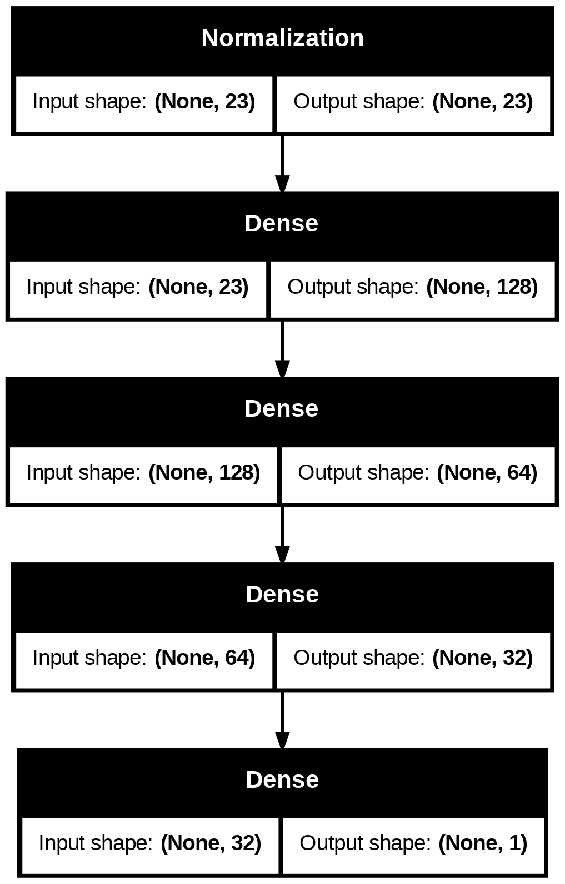
Figure 18: Neural Network Model 1 Architecture
The network began with the pretrained Normalization layer accepting 23 input features, which standardized all inputs before passing them to the hidden layers. The first hidden layer contained 128 neurons, the second contained 64 neurons, and the third contained 32 neurons, all using the Rectified Linear Unit (ReLU) activation function to introduce non-linearity and enable the model to learn complex relationships between features and price. The output layer consisted of a single neuron with no activation function, appropriate for a continuous regression target. The model contained a total of 13,488 parameters, of which 13,441 were trainable.
The model was compiled using the Adam optimizer with Mean Squared Error (MSE) as the loss function, and both MAE and MSE were tracked as evaluation metrics during training. The model was trained for 100 epochs with a batch size of 32 and a validation split of 20% applied to the training data, reserving 532 records for in-training validation.
Training Behavior
Figures 19 and 20 present the training and validation MAE and MSE curves respectively across all 100 epochs.
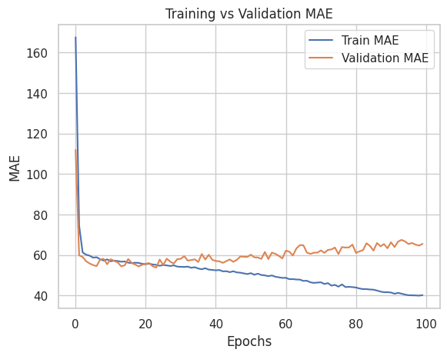
Figure 19: Neural Network Model 1 Training vs Validation MAE
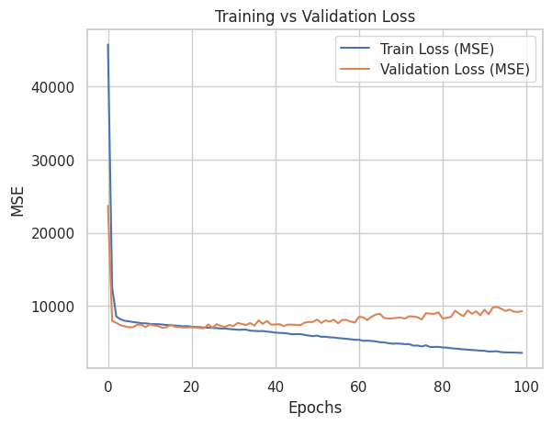
Figure 20: Neural Network Model 1 Training vs Validation Loss (MSE)
Both the training MAE and MSE declined sharply in the early epochs before stabilizing. However, a growing divergence between the training and validation curves became apparent beyond approximately epoch 40, with the training loss continuing to decrease while the validation loss plateaued and gradually increased. This divergence is indicative of overfitting, where the model began to memorize patterns in the training data rather than generalizing to unseen observations.
Model Performance
The evaluation results on the training and test sets are summarized below. On the training set, the model achieved an MAE of $43.64, MAPE of 28.10%, MSE of 4,528.46, RMSE of $67.29, R² of 0.7424, and Adjusted R² of 0.7401. On the test set, performance declined to an MAE of $61.72, MAPE of 41.05%, MSE of 7,889.82, RMSE of $88.82, R² of 0.5416, and Adjusted R² of 0.5321. The substantial gap between the training and test R² scores of 0.74 and 0.54 respectively confirms the presence of overfitting observed in the learning curves, indicating that the baseline model architecture required regularization to improve generalization to unseen data.

Neural Network Model 2: Regularized Architecture with Early Stopping
Model Architecture
The second neural network model was designed to directly address the overfitting observed in Model 1 by incorporating three regularization strategies: L2 weight regularization, Batch Normalization, and Dropout. The architecture, illustrated in Figure 21, expanded the network depth to four hidden layers while introducing these regularization components after each hidden layer.
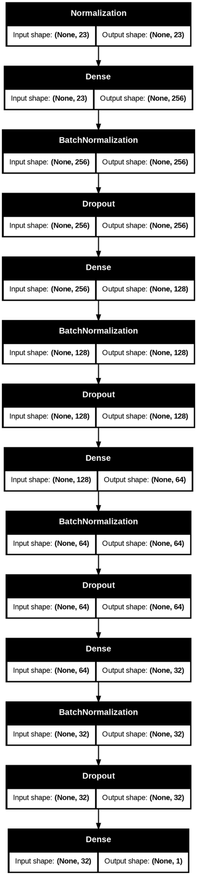
Figure 21: Neural Network Model 2 Architecture
Following the pretrained Normalization input layer, the first hidden layer contained 256 neurons with L2 regularization of 0.0004, followed by Batch Normalization and a Dropout rate of 0.3. The second hidden layer contained 128 neurons with the same L2 penalty, followed by Batch Normalization and a Dropout rate of 0.2. The third and fourth hidden layers contained 64 and 32 neurons respectively, each followed by Batch Normalization and a Dropout rate of 0.1. All hidden layers used the ReLU activation function. The output layer consisted of a single neuron with no activation function for continuous price regression. The model contained a total of 51,376 parameters, of which 50,369 were trainable, with 1,007 non-trainable parameters maintained by the Batch Normalization layers.
The model was compiled using the Adam optimizer with a learning rate of 0.001 and MSE as the loss function. An EarlyStopping callback was configured to monitor validation loss with a patience of 20 epochs and to restore the best weights upon stopping, preventing unnecessary training beyond the point of optimal generalization. The model was trained for a maximum of 300 epochs with a batch size of 32 and a 20% validation split, stopping early at epoch 60.
Training Behavior
Figures 22 and 23 present the training and validation MAE and MSE curves respectively across the training epochs.
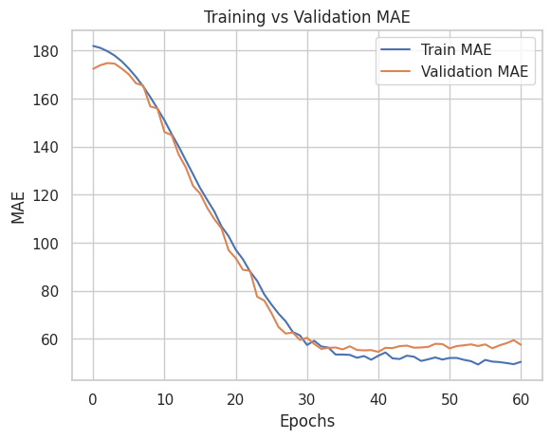
Figure 22: Neural Network Model 2 Training vs Validation MAE

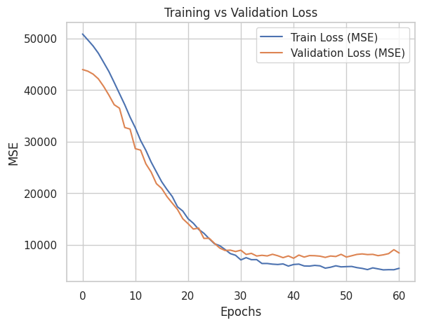
Figure 23: Neural Network Model 2 Training vs Validation Loss (MSE)
Both curves declined smoothly and in close alignment throughout training, with the training and validation losses converging near epoch 30 and remaining closely tracked thereafter. This parallel behavior demonstrates that the regularization techniques were effective in substantially reducing the overfitting observed in Model 1, producing a more stable and generalizable learning trajectory.
Model Performance
On the training set, Model 2 achieved an MAE of $43.68, MAPE of 27.66%, MSE of 4,539.80, RMSE of $67.38, R² of 0.7417, and Adjusted R² of 0.7395. On the test set, the model recorded an MAE of $43.68, MAPE of 27.66%, MSE of 4,539.80, RMSE of $67.38, R² of 0.7417, and Adjusted R² of 0.7395. The near-identical training and test metrics confirm that the regularization strategy was highly effective, eliminating the generalization gap seen in Model 1 while maintaining comparable predictive accuracy on the training set.

XGBoost Model with Hyperparameter Tuning
Model Overview
An XGBoost regression model was developed as a machine learning baseline to complement the neural network approach and provide a comparison of gradient boosting performance against deep learning for Airbnb price prediction. XGBoost is an ensemble learning method that builds a sequence of decision trees in a boosting framework, where each successive tree is trained to correct the residual errors of the previous trees, making it particularly effective for structured tabular data with complex non-linear feature interactions.
Hyperparameter Tuning
Grid Search Cross-Validation with 5-fold cross-validation was applied to systematically identify the optimal hyperparameter configuration. The search space covered the following parameters: n_estimators (100, 300, 500), learning_rate (0.03, 0.05, 0.1), max_depth (3, 4, 5), min_child_weight (5, 10), subsample (0.7, 0.9), colsample_bytree (0.3, 0.5, 0.7, 0.9), and gamma (0.1, 0.2). The R-squared score was used as the optimization metric across all cross-validation folds. The best-performing configuration identified through the search was subsequently fitted on the full training set.
Model Performance
On the training set, the tuned XGBoost model achieved an MAE of $36.37, MAPE of 25.78%, MSE of 2,758.08, RMSE of $52.52, R² of 0.8431, and Adjusted R² of 0.8417. On the test set, performance was an MAE of $53.71, MAPE of 35.91%, MSE of 6,598.25, RMSE of $81.23, R² of 0.6166, and Adjusted R² of 0.6087. While the training R² of 0.84 is notably strong, the gap between training and test performance indicates the presence of moderate overfitting, a common characteristic of gradient boosting models that can overfit to training data when the hyperparameter search space is large and the dataset is relatively small.

XGBoost Feature Importance
Figure 24 presents the relative feature importance scores derived from the trained XGBoost model, providing insight into which variables contributed most significantly to price prediction.
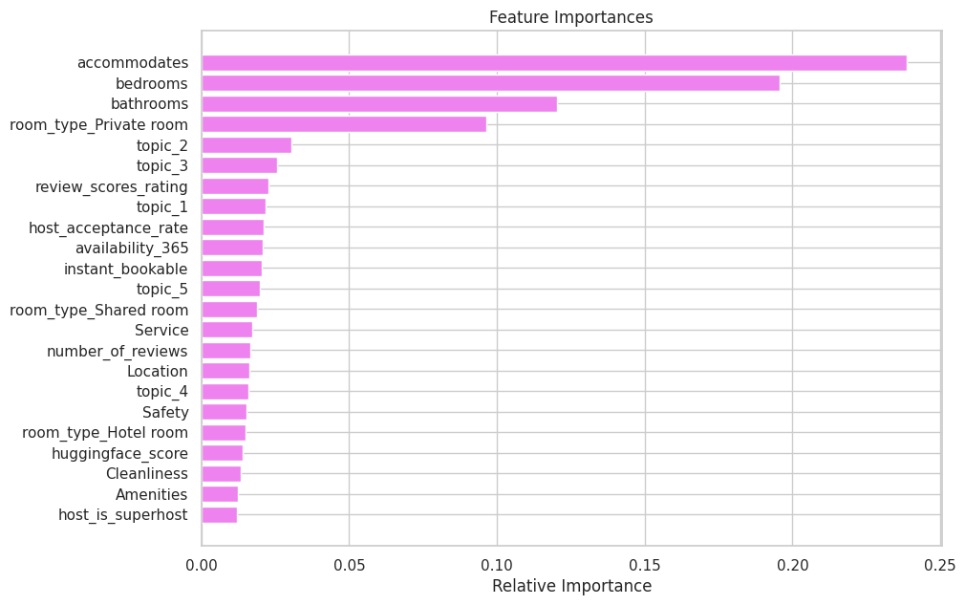
Figure 24: XGBoost Feature Importance
The feature importance results strongly reinforce the findings from the correlation analysis and bivariate exploration. Property size features dominated the model's predictive framework, with accommodates recording the highest relative importance of approximately 0.24, followed by bedrooms at 0.20 and bathrooms at 0.12. Together, these three features accounted for the majority of the model's predictive signal, confirming that physical property capacity is the primary determinant of listing price in the Chicago Airbnb market. The room_type_Private room indicator was the fourth most important feature at approximately 0.10, reflecting the substantial price differential between private room listings and the dominant entire home category.
Among the NLP-derived features, topic_2 and topic_3 emerged as the most influential, recording relative importances of approximately 0.03 and 0.025 respectively. This is particularly noteworthy as topic_2, associated with upscale property features and scenic views, showed a meaningful contribution to price prediction, suggesting that listings whose reviews emphasize premium building characteristics and views do command higher prices. topic_1 also contributed modestly, while topic_4 and topic_5 recorded the lowest importance among the LDA features. The zero-shot classification scores for Service, Location, Safety, Cleanliness, and Amenities each recorded low but non-zero importance values, as did the Hugging Face sentiment score, confirming that NLP-derived review features contribute a modest incremental signal to price prediction when combined with structural property characteristics.
The host_is_superhost feature recorded the lowest relative importance among all features, suggesting that superhost status alone has minimal direct influence on price within this modeling framework once property size and type are accounted for.

Model Comparison and Selection
Model | MAE | MAPE | MSE | RMSE | R² Score | Adj. R²
NN Model 1 (Training) | 55.35 | 36.04% | 7,410.16 | 86.08 | 0.5784 | 0.5747
NN Model 1 (Test) | 57.04 | 36.13% | 7,993.01 | 89.40 | 0.5356 | 0.5260
NN Model 2 (Training) | 57.31 | 39.67% | 7,532.71 | 86.79 | 0.5714 | 0.5677
NN Model 2 (Test) | 57.25 | 38.67% | 7,543.72 | 86.85 | 0.5617 | 0.5526
XGB Model (Training) | 36.37 | 25.78% | 2,758.08 | 52.52 | 0.8431 | 0.8417
XGB Model (Test) | 53.71 | 35.91% | 6,598.25 | 81.23 | 0.6166 | 0.6087
Table 1: Model Performance Comparison
Table 1 presents a consolidated comparison of all three models evaluated on both the training and test sets across six performance metrics.
Model Evaluation
Neural Network Model 1 achieved a training R² of 0.578 but showed a notable drop to 0.536 on the test set, confirming the overfitting behavior observed in its learning curves. Neural Network Model 2 addressed this through regularization and early stopping, producing closely aligned training and test R² scores of 0.571 and 0.562 respectively, demonstrating substantially improved generalization. However, both neural network models produced relatively modest R² scores overall, suggesting that the feedforward architecture with the current feature set did not fully capture the complexity of listing price variation.
The XGBoost model delivered the strongest overall performance, achieving the highest training R² of 0.843 and the best test R² of 0.617 among all models. It also recorded the lowest training MAE of $36.37 and the lowest test RMSE of $81.23, outperforming both neural network models on every metric. While a gap between training and test performance indicates some degree of overfitting, the XGBoost model's superior predictive accuracy on the test set establishes it as the best performing model in this study. The model's ability to capture non-linear feature interactions and its interpretable feature importance outputs make it the most suitable candidate for deployment in a listing price prediction framework for the Chicago Airbnb market.

Insights
The analysis yielded several key findings across both the NLP and price prediction objectives. Physical property attributes including accommodation capacity, number of bedrooms, and number of bathrooms emerged as the dominant determinants of listing price, collectively accounting for the majority of the model's predictive signal and confirming that property size is the primary value driver in the Chicago short-term rental market. Room type was the fourth most influential structural feature, with private room listings commanding considerably lower prices than entire home listings, reflecting the strong premium guests place on exclusive property access.
NLP-derived features including LDA topic scores, zero-shot classification scores across cleanliness, service, location, safety, and amenities, and transformer-based sentiment scores all contributed meaningful predictive signal to the models, validating the hypothesis that guest review content carries latent pricing information beyond what structured listing attributes alone can provide. The prominence of topic_2, associated with upscale property features and views, among the top NLP predictors further confirms that qualitative dimensions of guest experience captured through topic modeling are directly linked to listing valuation. The review scores rating also contributed meaningfully, indicating that consistently higher guest satisfaction translates into measurable pricing power for hosts.
The XGBoost model outperformed both neural network architectures on the test set across all error metrics, demonstrating that gradient boosted decision trees are particularly well suited for structured tabular Airbnb data. The regularized neural network model achieved the smallest train-to-test performance gap among all models, demonstrating the effectiveness of Batch Normalization, Dropout, L2 regularization, and early stopping in improving generalization. The persistent gap between training and test performance across all models indicates that high-priced listing outliers, neighborhood-level price heterogeneity, and seasonality factors not captured in the current feature set continue to limit full generalization to unseen listings.

Business Recommendations
For Airbnb: The platform should develop a dynamic pricing guidance tool powered by gradient boosting models that incorporates both structured listing attributes and NLP-derived review indicators, enabling real-time data-driven pricing recommendations tailored to individual markets. Airbnb should invest in scaling its review analytics infrastructure by systematically applying topic modeling, sentiment analysis, and zero-shot classification to guest reviews, transforming unstructured feedback into actionable quality indicators surfaced to both hosts and prospective guests. Guest sentiment trends and topic-based performance scores should be integrated into search ranking algorithms to ensure that listings with consistently positive experiences across cleanliness, service, location, and amenities receive greater platform visibility.
For Hosts: Hosts should prioritize maximizing accommodation capacity as the strongest and most direct lever for increasing revenue potential in the Chicago market. Those seeking a price premium should focus on consistently delivering high quality guest experiences across the key dimensions identified through zero-shot classification, particularly cleanliness, service responsiveness, and location accessibility. Hosts with private room listings should evaluate whether property modifications enabling full home access could unlock a substantially higher price tier, given that room type is among the top four most important pricing features identified by the model.
For Guests: Guests seeking the best value should use NLP-derived quality indicators such as sentiment scores, cleanliness ratings, and service scores alongside numerical star ratings when evaluating listings, as these signals provide a more nuanced picture of expected guest experience. Guests prioritizing affordability should consider private room listings while still evaluating sentiment and topic scores to ensure that the lower price point does not come at the expense of a satisfactory stay experience.

Conclusion
This project successfully addressed both objectives of conducting a comprehensive guest experience analysis and developing predictive pricing models for Airbnb listings in Chicago, Illinois. Through the application of sentiment analysis, zero-shot classification, and LDA topic modeling on guest review data, unstructured textual feedback was systematically transformed into measurable indicators of guest experience. These NLP-derived features were subsequently integrated with structured listing attributes to build and evaluate two neural network models and one XGBoost model for price prediction.
The XGBoost model emerged as the best overall performer, achieving a test R² of 0.6166 and a test RMSE of $81.23, outperforming both neural network architectures. Feature importance analysis confirmed that physical property attributes are the primary determinants of listing price, while NLP-derived topic scores, review ratings, and zero-shot classification scores contribute meaningful secondary predictive signal, validating the core hypothesis that guest review content carries latent pricing information beyond what structured features alone provide. The regularized neural network model demonstrated the most stable generalization behavior with the smallest train-to-test performance gap, highlighting the effectiveness of the regularization strategies employed. Collectively, these results demonstrate that integrating NLP-derived guest experience indicators with structured listing attributes produces a richer and more informative feature space for Airbnb price prediction, providing a scalable analytical framework that Airbnb, hosts, and guests can leverage to make more informed pricing, quality improvement, and booking decisions in the competitive Chicago short-term rental market.

Group Member Contributions
This section outlines the specific roles, tasks, and responsibilities undertaken by each team member throughout the duration of the project. As the project evolved across three key deliverables including the Colab notebook, the written report, and the presentation, responsibilities were distributed based on individual strengths and initial commitments.
Rohith Reddy Kolanu
Rohith served as the primary technical lead and coordinated the overall project pipeline from inception to completion. His contributions included leading the design and implementation of the end-to-end data pipeline, overseeing the application of all NLP techniques including VADER sentiment analysis, Hugging Face transformer-based sentiment classification, zero-shot classification, and LDA topic modeling, directing the development and training of both neural network architectures and the XGBoost model with hyperparameter tuning, and leading the feature importance analysis and model comparison. Rohith also took primary responsibility for structuring and writing the project report and ensured all deadlines were met across the team.
Allen Joe Winny Tharigopala
Allen played an active role in the data preprocessing and pipeline development stages of the project. His contributions included implementing the initial data loading and cleaning procedures, handling missing value treatment and type conversion steps within the Colab notebook, supporting the merging of NLP-derived features with the structured listings dataset, contributing to the exploratory data analysis visualizations, and documenting the preprocessing decisions across the pipeline. Allen also contributed to the writing and formatting of the data exploration and preprocessing sections of the report.
Ruthwik Reddy Kolanu
Ruthwik contributed actively to the feature engineering, modeling, and evaluation stages of the project pipeline. His responsibilities included supporting the feature selection and encoding processes for model preparation, contributing to the implementation of the model evaluation framework and performance metric calculations, assisting with the development and testing of the neural network model configurations, supporting the interpretation of model outputs and feature importance results, and contributing to the documentation of modeling decisions within both the Colab notebook and the written report. Ruthwik also supported the preparation and content development of the project presentation.
Gianni Colonero
Gianni contributed actively to the topic modeling, visualization, and presentation stages of the project pipeline. His responsibilities included supporting the implementation and interpretation of NMF and LSA topic modeling outputs, contributing to the generation and organization of visual outputs including topic word clouds, bar charts, PCA topic distance plots, and geographic price distribution maps, assisting with the BERTopic analysis and its diagnostic visualizations, contributing to the written documentation of topic modeling results in the report, and leading the preparation and design of the project presentation slides to effectively communicate the findings to stakeholders.

Generative AI Usage
Generative AI tools like Claude were selectively utilized at specific stages of the project to enhance productivity and support the analytical workflow.
All AI-assisted outputs were critically reviewed, validated, and refined by the project team to ensure accuracy and alignment with the project objectives.
Resources
- Inside Airbnb Data:
  - https://insideairbnb.com/get-the-data/
- Airbnb Data Dictionary:
  - https://docs.google.com/spreadsheets/d/1iWCNJcSutYqpULSQHlNyGInUvHg2BoUGoNRIGa6Szc4/edit?usp=sharing

Appendix
Appendix A: Topic Distance Visualizations (PCA)
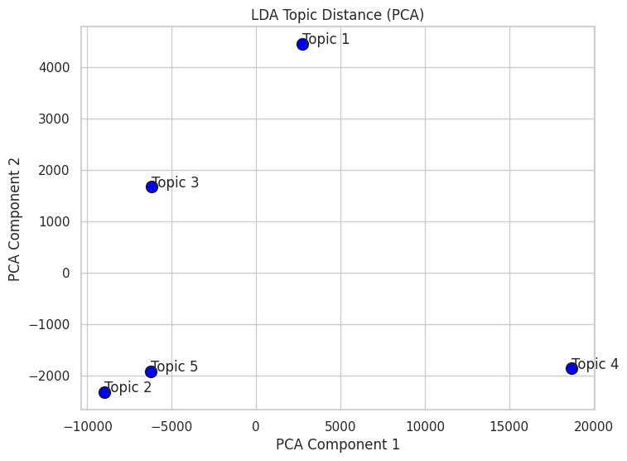
Figure A1: LDA Topic Distance (PCA)
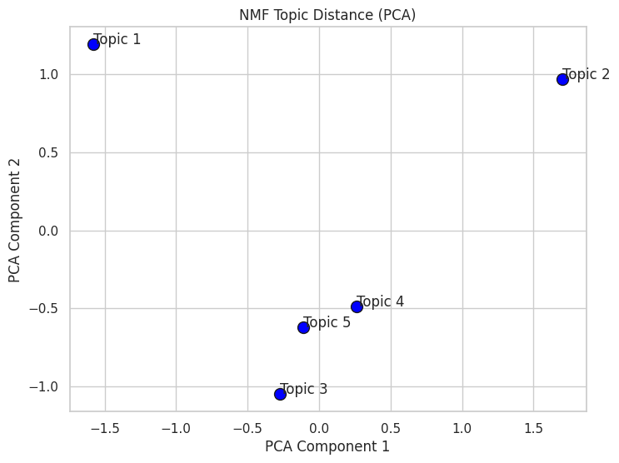
Figure A2: NMF Topic Distance (PCA)
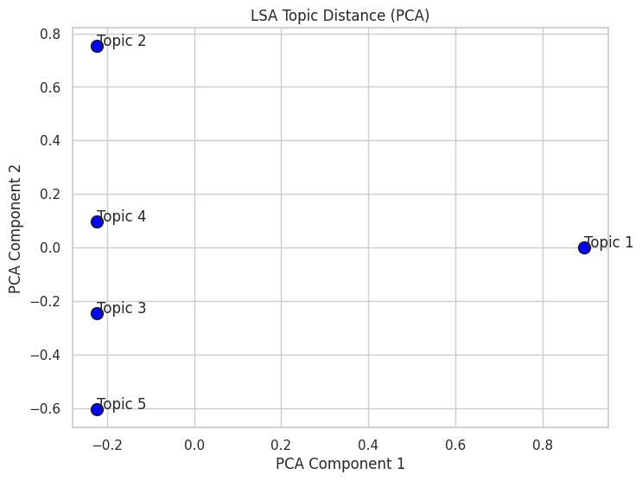
Figure A3: LSA Topic Distance (PCA)
Appendix B: BERTopic Diagnostic Visualizations
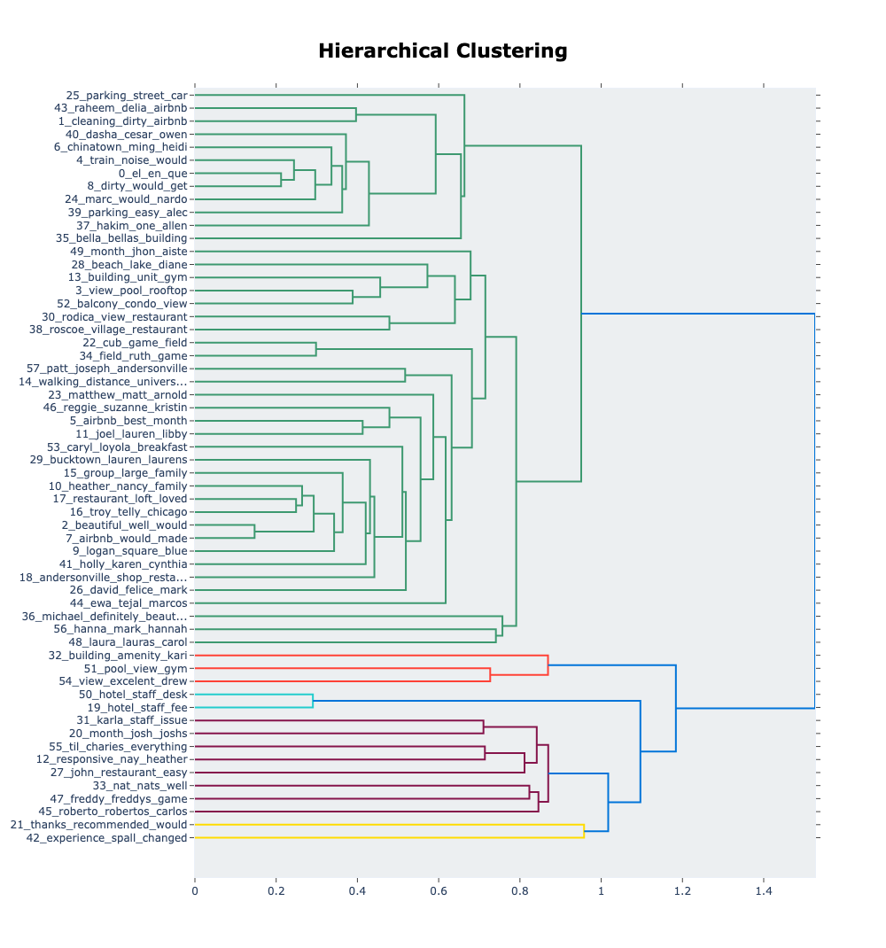
Figure B1: BERTopic Hierarchical Clustering Dendrogram
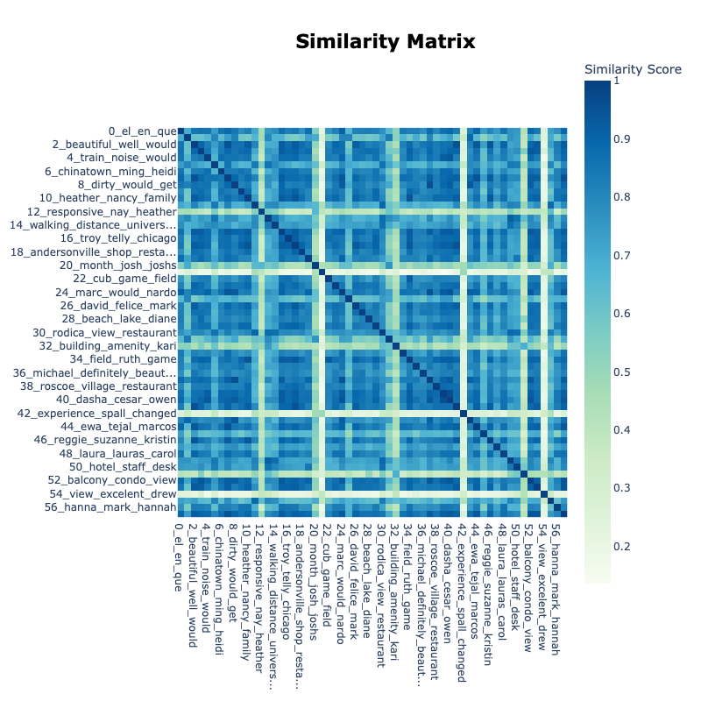
Figure B2: BERTopic Topic Similarity Matrix (Heatmap)
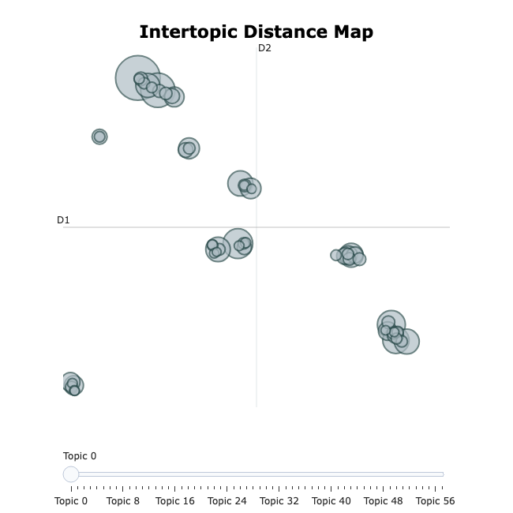
Figure B3: BERTopic Intertopic Distance Map
Appendix C: Geographic Visualization
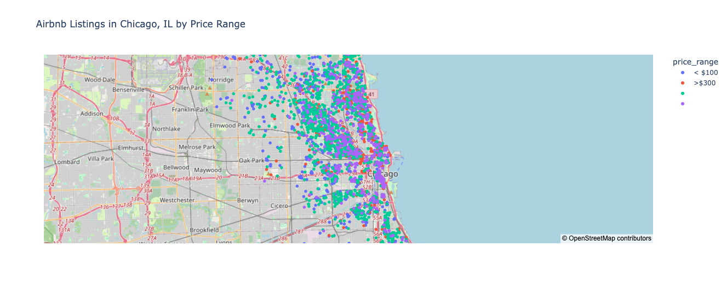
Figure C1: Airbnb Listings in Chicago, IL by Price Range (Interactive Map)

